Project Report

|  |  |
| --- | --- |
| Project title | Predicting Recidivism applying IRAC method |
| Module Name | **NICF Statistical Thinking for Data Science and Analytics (SF)** |
| Qualification Name | **NICF Diploma in Infocomm Technology (Data)** |
|  |  |

|  |  |  |  |
| --- | --- | --- | --- |
| Student name | | Assessor name | |
| Syed Shabana | | Ryan | |
| Date issued | Completion date | | Submitted on |
| 24-03-2021 | 27-03-2021 | | 27-03-2021 |
|  | |  | |
| Project title | Student Registration Form Development | | |

|  |
| --- |
| Learner declaration |
| I certify that the work submitted for this assignment is my own and research sources are fully acknowledged.  Student signature: Date: 27/3/2021 |

Content

1. Project Overview 2,3
2. Project Technical Environment 3-4
3. Analytical Technique & Tools Used

3.1 Data Collection 5

3.2 Data Storage 5

3.3 Data Cleaning 6

3.4 Data Analysis 6-9

3.5 Visualization 9

3.6 Decision 9

1. IRAC Analysis and Objectives 10-11
2. Project Implementation

Task1:Risk of Recidivism Prediction 11-17

Task2:Risk of Violent Recidivism Prediction 17-21

Task3: Accuracy of Prediction in Recidivism Category 21-28

Task4:Accuracy of Prediction in Violent Recidivism Category 29-35

Task5: IRAC Analysis of a Using Sentencing Algorithm 35-36

1. Conclusion 36-

37

7.Appendix………………………………………………………………………………………………………………..37

1. **Project Overview:** Describe the Project with summary of analytical processes and project outcomes (Explain the Project in your own words in 15 – 20 lines)

In this project, we will use data released by ProPublica of criminal justice records from Broward County, Florida. The data that we collected consists of four .csv datasets. Where each corresponds to a specific purpose of study in the data mining lab. The files are ‘compas-scores-two-years.csv’,‘compas-scores-two-years-violent.csv’,‘cox-parsed.csv’and‘cox-violent-parsed.csv’.

The datasets contain information of 10000 criminal defendants who had been assessed with the COMPAS (which stands for Correctional Offender Management Profiling for Alternative Sanctions) screening system. The Correctional Offender Management Profiling for Alternative Sanctions (COMPAS) is a tool for assessing risk and needs for offenders in correctional settings developed by Northpointe Institute for Public Management, Incorporated. Risk may be defined as the likelihood of re- offending in the future. The COMPAS data has details in between January 1, 2013, and December 31, 2014. Each observation comes with more than 50 variables in the datasets.

We set out to assess one of the commercial tools made by Northpointe, Inc. to discover the underlying accuracy of their recidivism algorithm and to test whether the algorithm was biased against certain groups.

Our analysis of Northpointe’s tool, called COMPAS (which stands for Correctional Offender Management Profiling for Alternative Sanctions), found that black defendants were far more likely than white defendants to be incorrectly judged to be at a higher risk of recidivism, while white defendants were more likely than black defendants to be incorrectly flagged as low risk.

We looked at more than 10,000 criminal defendants in Broward County, Florida, and compared their predicted recidivism rates with the rate that actually occurred over a two-year period. When most defendants are booked in jail, they respond to a COMPAS questionnaire. Their answers are fed into the COMPAS software to generate several scores including predictions of “Risk of Recidivism” and “Risk of Violent Recidivism.”

We compared the recidivism risk categories predicted by the COMPAS tool to the actual recidivism rates of defendants in the two years after they were scored and found that the score correctly predicted an offender’s recidivism 61 percent of the time but was only correct in its predictions of violent recidivism 20 percent of the time.

In forecasting who would re-offend, the algorithm correctly predicted recidivism for black and white defendants at roughly the same rate (59 percent for white defendants, and 63 percent for black defendants) but made mistakes in very different ways. It misclassifies the white and black defendants differently when examined over a two-year follow-up period.

Our analysis found that:

Black defendants were often predicted to be at a higher risk of recidivism than they actually were. Our analysis found that black defendants who did not recidivate over a two-year period were nearly twice as likely to be misclassified as higher risk compared to their white counterparts (45 percent vs. 23 percent).

White defendants were often predicted to be less risky than they were. Our analysis found that white defendants who re-offended within the next two years were mistakenly labeled low risk almost twice as often as black re-offenders (48 percent vs. 28 percent).

The analysis also showed that even when controlling for prior crimes, future recidivism, age, and gender, black defendants were 45 percent more likely to be assigned higher risk scores than white defendants.

Black defendants were also twice as likely as white defendants to be misclassified as being a higher risk of violent recidivism. And white violent recidivists were 63 percent more likely to have been misclassified as a low risk of violent recidivism, compared with black violent recidivists.

The violent recidivism analysis also showed that even when controlling for prior crimes, future recidivism, age, and gender, black defendants were 77 percent more likely to be assigned higher risk scores than white defendants.

We will examine the individual accuracy of the predicted recidivism rates, violent recidivism rates, and lastly the overall accuracy of COMPAS in the respective categories. In addition to the lab, we will work on an IRAC scenario with respect to this particular lab.

**The project outcome including:**

* Summaries of the studies on the accuracy of predicted recidivism rates, violent recidivism rates and the overall accuracy of COMPAS in respective categories.
* Calculations and visualizations using R and Python within Jupyter Notebook
* IRAC analysis with respect to this particular lab

1. **Project Technical Environment:** (Describe the AML, Jupyter Notebooks)

**Jupyter Notebooks:**



For this project, we use Jupyter Notebooks. Notebooks Preview to run Jupyter notebooks to study the lab in R, Python2 and Python 3.6 kernels.

“Jupyter" is a loose acronym meaning Julia, Python, and R. These programming languages were the first target languages of the Jupyter application, but nowadays, the notebook technology also supports [many other languages](https://github.com/jupyter/jupyter/wiki/Jupyter-kernels). The main components of the whole environment are, on the one hand, the notebooks themselves and the application. On the other hand, you also have a notebook kernel and a notebook dashboard.

As a server-client application, the Jupyter Notebook App allows you to edit and run your notebooks via a web browser. The application can be executed on a PC without Internet access, or it can be installed on a remote server, where you can access it through the Internet.

Its two main components are the kernels and a dashboard.

A kernel is a program that runs and introspects the user’s code. The Jupyter Notebook App has a kernel for Python code, but there are also kernels available for other programming languages.

The dashboard of the application not only shows you the notebook documents that you have made and can reopen but can also be used to manage the kernels: you can which ones are running and shut them down if necessary.

A web application:

A browser-based tool for interactive authoring of documents which combine explanatory text, mathematics, computations and their rich media output.

Notebook documents:

A representation of all content visible in the web application, including inputs and outputs of the computations, explanatory text, mathematics, images, and rich media representations of objects. It can be used for data cleaning and transformation, numerical simulation, statistical modeling, data visualization, machine learning, and much more.

**Azure Notebooks:**

Azure Note Booksare public Jupyter server hosted in the Azure cloud, which you can use from anywhere through the browser to write your code. There are many advantages of using [Azure Notebooks](http://notebooks.azure.com/?WT.mc_id=devto-blog-dmitryso) instead of local Jupyter installation.

* Access to your Code from Anywhere
* Easily Share Code
* Write Documented Code / Data-Driven Journalism
* Make Presentations
* Clone-and-Run any GitHub Repo
* Run the Code on Different Compute
* Can teach easily
* Multiple language support: Supporting more languages than any other platform including Python 2, Python 3, R, and F#.

1. **Analytical Technique & Tools used:** Describe the Analytical Technique and Tools used in the Project

For this project we are validating

* + - Risk of Recidivism Prediction
    - Risk of Violent Recidivism Prediction
    - Overall Accuracy in Predicting Recidivism
    - Overall Accuracy in Predicting Violent Recidivism

To predict the above scenarios followed the below steps and analysed the above points.

For this we first collected data and stored. Cleaned the missing data or duplicate values and removed ordinary traffic offenses , those with a c_charge_degree of 'O' will not result in Jail time are removed .Analysed the data like how the recidivism is predicted and visualized and then came to conclusion what are the factors causing recidivism.

Set of sequential steps to flow through for each section of our lab

**3.1 Data Collection**

Through a public records request to Broward County Sheriff’s Office (BCSO) in Florida, ProPublica obtained two years’ worth of COMPAS scores for over 18,000 people. Then, they filtered the data to include only those rows representing people who had either recidivistic in two years, or had at least two years outside of a correctional facility. Upon the relevant filtering, that left over 11,000 people.

Starting with the database of COMPAS score, they then built the individual criminal history profile using

* public criminal records from the Broward County Clerk’s Office website,
* jail records from BCSO and
* public incarceration records from Florida Department of Corrections website.

**3.2 Data Storage**

The data that contains information of over 10,000 criminal defendants who had been assessed with the COMPAS screening system between January 1, 2013, and December 31, 2014, is stored in the format of .CSV and there are four files: ‘compas-scores-two-years.csv’, ‘compas-scores-two-years-violent.csv’, ‘cox-parsed’ and ‘cox-violent-parsed’.

3.3 Data Cleaning

Data cleaning of rows were performed based on the following conditions.

**Variable: days_b_screening_arrest**

Meaning: Number of days between screening date and arrest/charge date. Numeric values.

Issue: We considered cases with arrest dates/charge dates within 30 days of a COMPAS. assessment being conducted. For duration not within 30, we assume that because of data quality reason, or that we do not have the right offense.

Solution: Remove row(s) with values of less than or equal to 30, and of greater than or equal to -30.

**Variable: is_recid**

Meaning: A recidivist flag, to indicate whether a person recommit crime within two years or not. Binary values (0, 1).

Issue: -1 indicates we could not find a COMPAS case at all.

Solution: Remove row(s) with values of ‘-1’.

**Variable: c_charge_degree**

Meaning: description of the charge. F- Felony, M- Misdemeanor.

Issue: ‘O’ indicates will not result in jail time.

Solution: Remove row(s) with values of ‘O’.

We filtered the underlying data from Broward county to include only those rows representing people who had either recidivated in two years, or had at least two years outside of a correctional facility.

* Removed duplicate id values from Cox dataset.
* Removed N/A values from score_text and v_score_text variables.

**3.4 Data Analysis**

In this project, we will run the COMPAS analysis lab using Jupyter notebook within Azure Notebooks Preview. Different kernels will be used including Python2 and Python 3.6 so as to execute the code successfully.

**Modules**

The table below listed the modules used in the lab.

|  |  |  |
| --- | --- | --- |
| **Module** | **Function** | **Use** |
| pandas | * In python it provides many data manipulation tasks, to help us translate our thoughts into code. | * Retrieve data by using db.loc or db[[]]. * pd.get_dummies() is used to do one hot encoding which converts categorical data to numeric values using binary representation. * concat( ) is used to concat two tables. |
| math | * It is a standard module in Python and is always available. To use mathematical functions under this module, you have to import the module using import math. | * math.exp ( ), to calculate number in exponential form, it accepts a number and returns the number in the exponential format (if the number is x, it returns e**x. |

By using different panda functions and by using matplot visualized and analyzed the data for race, sex, and age group how recidivism is given on different conditions.

**Models**

Two main models are used in the lab comprising logistic regression model and cox model.

**Logistic Regression**

Logistic Regression was used in the biological sciences in early twentieth century. It was then used in many social science applications. Logistic Regression is used when the dependent variable(target) is categorical.

For example,

To predict whether an email is spam (1) or (0)

Whether the tumour is malignant (1) or not (0)

Consider a scenario where we need to classify whether an email is spam or not. If we use linear regression for this problem, there is a need for setting up a threshold based on which classification can be done. Say if the actual class is malignant, predicted continuous value 0.4 and the threshold value is 0.5, the data point will be classified as not malignant which can lead to serious consequence in real time.

From this example, it can be inferred that linear regression is not suitable for classification problem. Linear regression is unbounded, and this brings logistic regression into picture. Their value strictly ranges from 0 to 1.

Simple Logistic Regression

Model

Output = 0 or 1

Hypothesis => Z = WX + B

hΘ(x) = sigmoid (Z)

Sigmoid Function

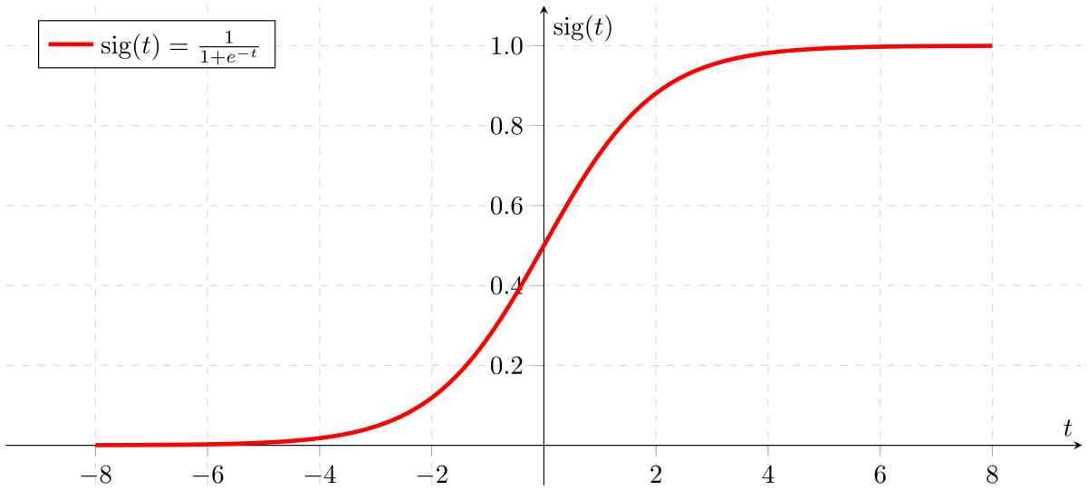

Sigmoid Activation Function

If ‘Z’ goes to infinity, Y(predicted) will become 1 and if ‘Z’ goes to negative infinity Y(predicted) will become 0.

For this project, Logistic Regression model was used to analyse relationship between independent variables and a dependant variable, when holding all other predictors constant/controlled. Multiple predictors were fit into the model, including gender, age, race, criminal history (priors_count), charge degree and future recidivism (decile score for risk of recidivism/risk of violent recidivism). The output/estimates (coefficients of the predictors) of a Logistic Regression model are in units called logits. Calculation was performed to convert these logits to odd ratios (OR).

Python sklearn package is used to compute the Logistic Regression model by using Logistic Regression () and fit the model by using fit()

**Cox Proportional Hazards Model/Cox Model:**

It is a survival model, also known as “time to event analysis” or “event history analysis”. It measures the time in a sample of people, animals, or machines until a specific event occurs. **Survival analysis** corresponds to a set of statistical approaches used to investigate the time it takes for an event of interest to occur.

**Survival analysis** is used in a variety of field such as:

Cancer studies for patient’s survival time analyses, Sociology for “event-history analysis”,

and in engineering for “failure-time analysis”.

In cancer studies, typical research questions are like:

* What is the impact of certain clinical characteristics on patient’s survival
* What is the probability that an individual survives 3 years?
* Are there differences in survival between groups of patients?

It is used to evaluate simultaneously the effect of several factors on survival/success. In other words, it allows us to examine how specified factors influence the rate of a particular event happening (e.g., infection, death, failure) at a particular point in time.

For our project, a person was “at risk” from the day he/she was given a COMPAS score; a person “survive” if he/she did not recidivate within two years; or otherwise “not survive” if he/she recidivate within two years. Counting model was used to compare rates of recidivism (while controlling for time) as well as to validate the COMPAS’s overall predictive accuracy, by looking at the estimates (coefficients), calculation based on the estimates and concordance value.

Python function used to compute the Cox model: CoxPHFitter ().Which is imported from lifelines package. For survival used KaplanMeierFitter () function to see during parole time (which is 2 years). Within 2 years he or she convicted crime or not has been analysed using the plots with KaplanMeierFitter (). How many people survived in their 2 years parole.

**3.5 Visualization**

The table below listed the modules used for visualization in the lab.

|  |  |  |
| --- | --- | --- |
| Module | Function | Use |
| matplotlib | * It is a data visualization package for Python. * It is based on the grammar of graphics, the idea that we can build every graph. | By using matplotlib we can plot all statistical plots like histogram, scatterplot, line plot, bar chart and different type of plots. |
| kmf.survival_function_.plot | * It is used to see survival plots of particular event. | * KaplanMeierFitter()to create a survival object, usually used as a response variable in a model formula. * KaplanMeierFitter().fit() to compute an estimate of a survival curve for censored data using either the Kaplan-Meier or the Fleming-Harrington method or computes the predicted survivor function for a Cox proportional hazards model. |

3.6 Decision

Decision for each section of the lab is the conclusion of the findings based on the data exploration, visualization and analysis performed.

1. **IRAC Analysis and Objectives**

IRAC is a method of organising with an analysis. IRAC is a structure that allows the reader like professor, judge to evaluate easily and systematically evaluate the analysis. IRAC is an acronym that generally stands for: Issue, Rule, Application, and Conclusion. It functions as a methodology for legal analysis. The IRAC format is mostly used in hypothetical questions in. One of the objectives for this is to move beyond learning about analytics and artificial intelligence, to applying legal analysis to issues that arise for us as a data professional in this field.

IRAC is the traditional method for analysing legal problems that arise in any context. It is also a time-tested straightforward problem solving tool that can be applied to other disciplines to help us work logically from identifying a legal issue to reaching a conclusion and a decision about how to take action. IRAC stands for Issue, Rule, Application and Conclusion.

**Issue**

In IRAC method of legal analysis, the "issue" is simply a legal question that must be answered. An issue arises when the facts of a case present a legal ambiguity that must be resolved in a case, and legal researchers (whether paralegals, law students, lawyers, or judges) typically resolve the issue by consulting legal precedent (existing statutes, past cases, court rules, etc.). For example, suppose the law required that a lawsuit had to be filed within one year of an allegedly negligent act.

By equipping ourselves with foundations of legal analysis, we will be more capable of identifying potential legal problems and making strategic decisions that are lawful. Furthermore, we will be better able to reveal the lack of law that exists for the rapidly evolving technologies and analyse the issues using ethical lens.

**Rule**

The “rule” is the rule of law that applies to the legal question. For example, if the issue is privacy and the situation concerns citizens in the European Union, the rule of law would likely be all or part of the General Data Protection Regulation. The rules help make a correct legal analysis of the issue at hand using the facts of the case. The rules section needs to be a legal summary of all the rules used in the analysis and is often written in a manner which paraphrases or otherwise analytically condenses information into applicable rules.

**Application**

The Application (or Analysis) section of an IRAC applies the rules developed in the rules section to the specific facts of the issue at hand. This section uses only the rules stated in the rules section of the IRAC and usually utilizes all the rules stated including exceptions as is required by the analysis. It is important in this section to apply the rules to the facts of the case and explain or argue why a particular rule applies or does not apply in the case presented. The application/analysis section is the most important section of an IRAC because it develops the answer to the issue at hand. It is useful to think like a lawyer, arguing the facts of the matter from both sides while sticking to the rules before coming to a decision.

This element of the methodology is where we will use our reasoning capabilities to think through how the rule should be applied to the situation at hand.

**Conclusion**

The Conclusion section of an IRAC directly answers the question presented in the issue section of the IRAC. It is important for the methodology of the IRAC that the conclusion section of the IRAC not introduce any new rules or analysis. This section restates the issue and provides the final answer. Conclusion is a vital process where the final calls are distributed upon the previous cases and are redefined by the judge. When we decide how the rule should be applied, we will have reached the “conclusion”. Ultimately, this is the answer to the issue or legal question presented in the beginning of the analysis.

In this project, an example of IRAC application with respect to the lab is included. See Section 5.5 IRAC Analysis of a Using Sentencing Algorithm for more detail.

1. **Project Implementation**

First of all, we will get to the background of the COMPAS Analysis Lab briefly.

**Why COMPAS?**

ProPublica chose to examine the COMPAS algorithm because it is one of the most popular scores used nationwide in the U.S. and is increasingly being used in pretrial and sentencing, the so-called “front-end” of the criminal justice system.

**Why Broward County?**

It chose Broward County because it is a large jurisdiction using the COMPAS tool in pretrial release decisions and Florida has strong open-records laws.

**What is a COMPAS score?**

COMPAS is reported in deciles, or increments of ten points. If one scores a 4 on a scale, then 60% of the population looks more risky in that area than he does, and 30% looks less risky. It is important to note that decile scores can only be interpreted in a relative sense, and are always linked to the norm group. COMPAS scores for each defendant ranged from 1 to 10, with ten being the highest risk. Scores 1 to 4 were labelled by COMPAS as “Low”; 5 to 7 were labelled “Medium”; and 8 to 10 were labelled “High.”

**Task 1:** **Risk of Recidivism Prediction:**

Defining recidivism was key to our analysis.

In [a 2009 study examining the predictive power of its COMPAS score](http://cjb.sagepub.com/content/36/1/21.abstract), Northpointe defined recidivism as “a finger-printable arrest involving a charge and a filing for any uniform crime reporting (UCR) code.” We interpreted that to mean a criminal offense that resulted in a jail booking and took place after the crime for which the person was COMPAS scored.

It was not always clear, however, which criminal case was associated with an individual’s COMPAS score. To match COMPAS scores with accompanying cases, we considered cases with arrest dates or charge dates within 30 days of a COMPAS assessment being conducted. In some instances, we could not find any corresponding charges to COMPAS scores. We removed those cases from our analysis.

Next, we sought to determine if a person had been charged with a new crime subsequent to crime for which they were COMPAS screened. We did not count traffic tickets and some municipal ordinance violations as recidivism. We did not count as recidivists people who were arrested for failing to appear at their court hearings, or people who were later charged with a crime that occurred prior to their COMPAS screening.

**Datasets**

* The dataset **used for risk of recidivism prediction is ‘**compas-scores-two-years.csv’.
* It has 7,214 rows. Each row in the file represents a person and is coupled with 53 variables (columns).
* The variables can be categorized as the following:

|  |  |
| --- | --- |
| **Type of Variable** | **Example of Variable** |
| Created from collected data | Personal data (name, age, sex, d.o.b., race), criminal records, jail records, incarceration records, screening dates. |
| Assigned by user | ID, derived columns for collected data (first name, last name, age category.) or generated by algorithm (type of assessment), calculate data (start, end, event, two_year_recid) |
| Generated by algorithm | COMPAS scores for recidivism (decile_score, score_text) and violent recidivism (v_decile_score, v_score_text) |

**Data Cleaning**

There are a number of reasons remove rows because of missing data:

If the charge date of a defendants Compas scored crime was not within 30 days from when the person was arrested, we assume that because of data quality reasons, that we do not have the right offense.

We coded the recidivist flag - is_recid -- to be -1 if we could not find a compas case at all.

In a similar vein, ordinary traffic offenses those with a c_charge_degree of 'O' will not result in Jail time are removed (only two of them).

We filtered the underlying data from Broward county to include only those rows representing people who had either recidivated in two years, or had at least two years outside of a correctional facility.

* Here in the first step, we read the CSV file and then understand the field values.
* In the next step selected the columns like

age,c_charge_degree,race,age_cat,score_text,sex,prior_count,daya_b_screening_arrest,decile_score,is_recid,two_year_recid,c_jail_in,c_jail_out fields to predict the model

* By using the above columns selected the rows that are needed based on different conditions like days_b_screening_arrest<=30 and days_b_screening>=-30 those values have been selected.
* Selected rows with is_recid!=-1 and c_charge of degree!=’O’, score_text!=NA
* So after data cleaning with the above conditions my resulting dataset consists of 6172 rows.

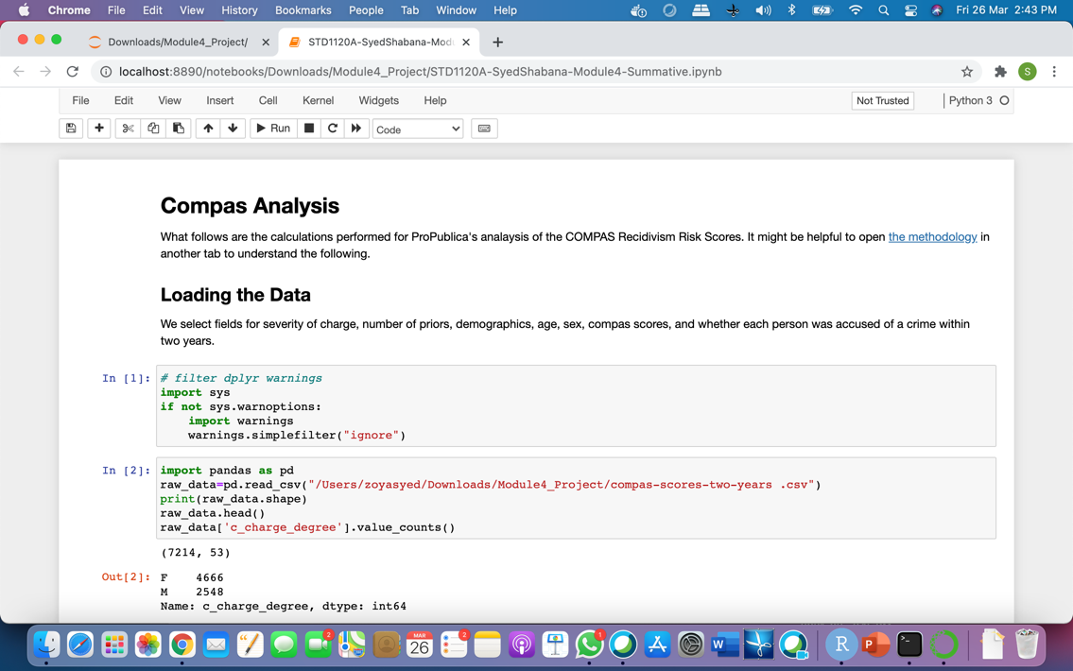

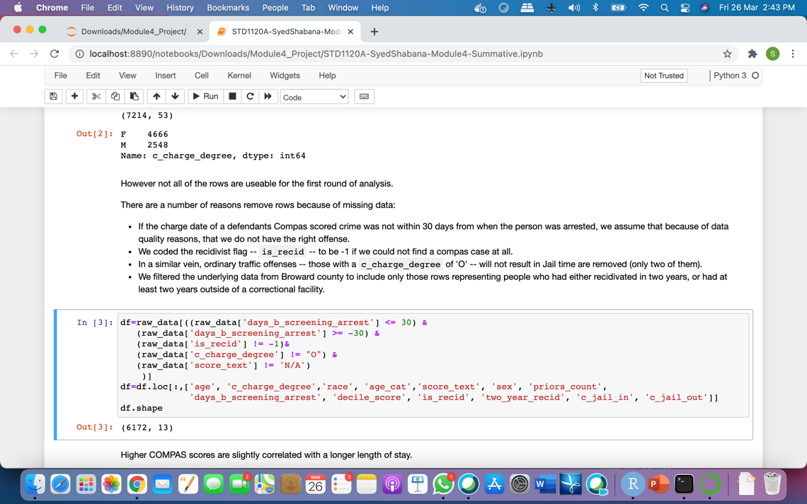

Data Exploration

Analyzed correlation between recidivism scores(which is decile_score) and jail period .Calculated Correlation using Pearsonr () between the fields length of stay and decile_score Length of stay is calculated by subtracting c_jai_in, from c_jail_out as given name as length of stay. The result in recidivism scores is weakly correlated to jail period at 0.207.

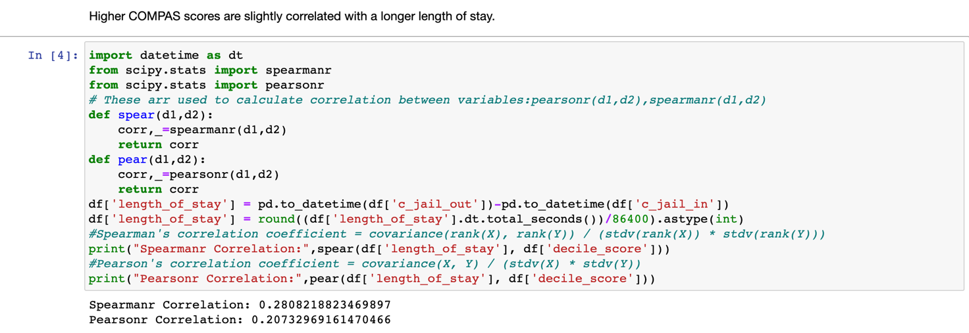

* Analyze demographic breakdown of the dataset:

|  |  |
| --- | --- |
| **Univariate data exploration** | **Bivariatedata exploration** |
| * age_cat (count) * race (count,% count) * score_text (count) * sex (count, % to Total) * two_year_recid (count,% count) | * sex vs race (count) |

Here we can see we have count of age category and race count.25-45 age group have large number. And when it comes to race African-American race count is large.51.44% of them are from African-American race.1144 defendants with high score. If we see gender. Majority of them are Male defendants.

45.51% of them are Recidivists as per data.

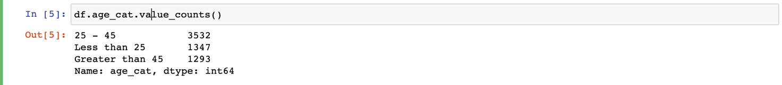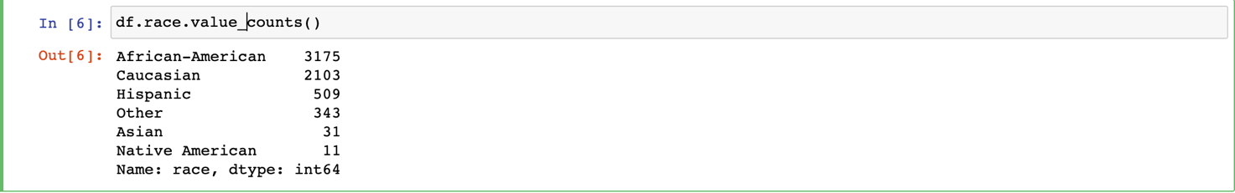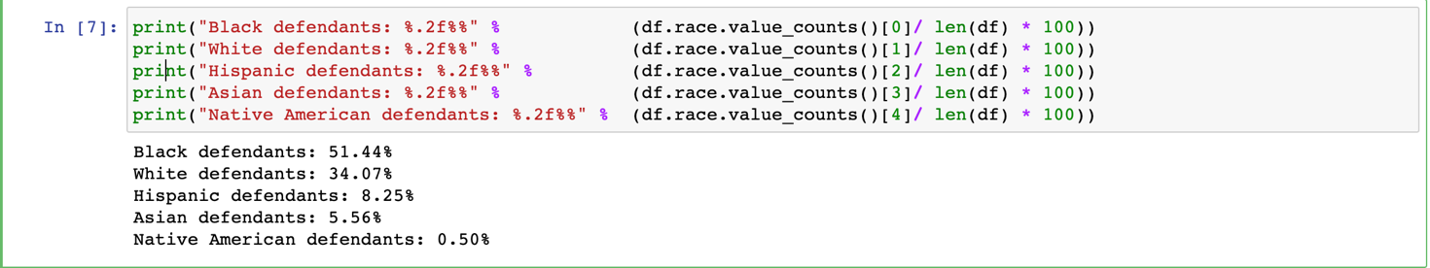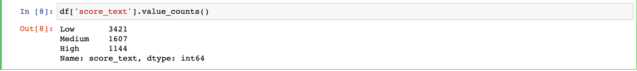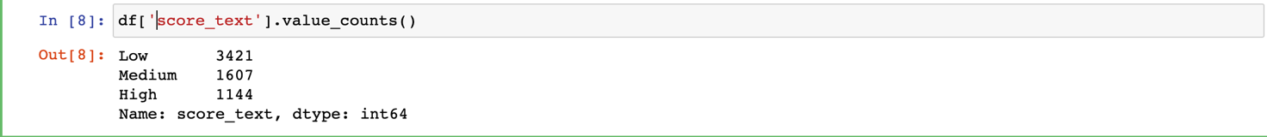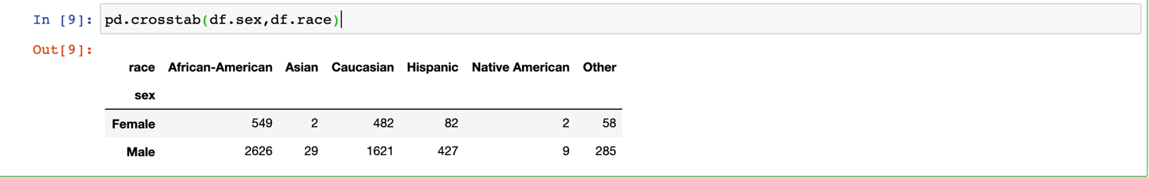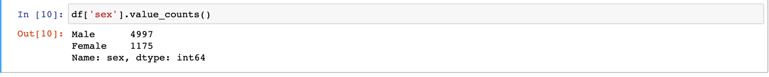

**Visualization**

Here Decile score is classified as 3 categories.1-4 Decile Score considered as Low risk,5-7 Decile score is considered as Medium risk and 8 to 10 Decile score is considered as High score.

* Plotted the simple distribution of COMPAS recidivism decile scores between white defendants and black defendants.
* If we see the graph, Black defendant’s count for all deciles is in same range but if we see the White Defendants Decile score the number of defendants with Decile score 1 is more. Many of the Defendants Decile score is given as low. If we look at the graph the high risk decile score for White defendants is very low than black Defendants.
* Tabulate all defendants with respect to COMPAS decile score for recidivism.

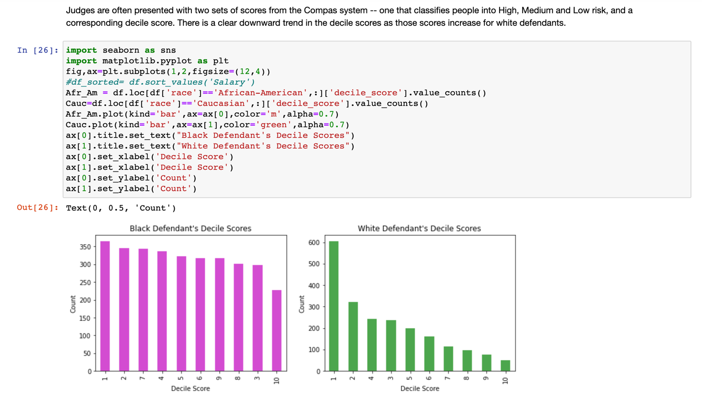

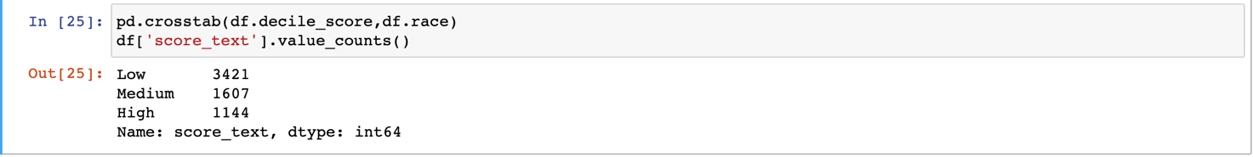

These histograms show that scores for white defendants were skewed toward lower-risk categories, while black defendants were evenly distributed across scores. In our two-year sample, there were 3,175 black defendants and 2,103 white defendants, with 1,175 female defendants and 4,997 male defendants. There were 2,809 defendants who recidivated within two years in this sample.

**Data Analysis**

Test Racial Bias in the Category of Risk of Recidivism

To test racial disparities in the score controlling for other factors, we created a logistic regression model we considered race, age, criminal history, future recidivism, charge degree, gender and age. We used those factors to model the odds of getting a higher COMPAS score.

According to Northpointe’s (the company that developed COMPAS) practitioners guide, COMPAS “scores in the medium and high range got more interest from supervision agencies than low scores, as a low score would suggest there is little risk of general recidivism,” so we considered scores any higher than “low” to indicate a risk of recidivism.

As we have race, age, gender values are strings. So for predicting we need to have numeric values for that purpose I used hot encoding of those fields using pd.get_dummies. This will divides each category as one new column with binary values. After that used Logistic regression model by using sklearn package in Python. We used logistic regression

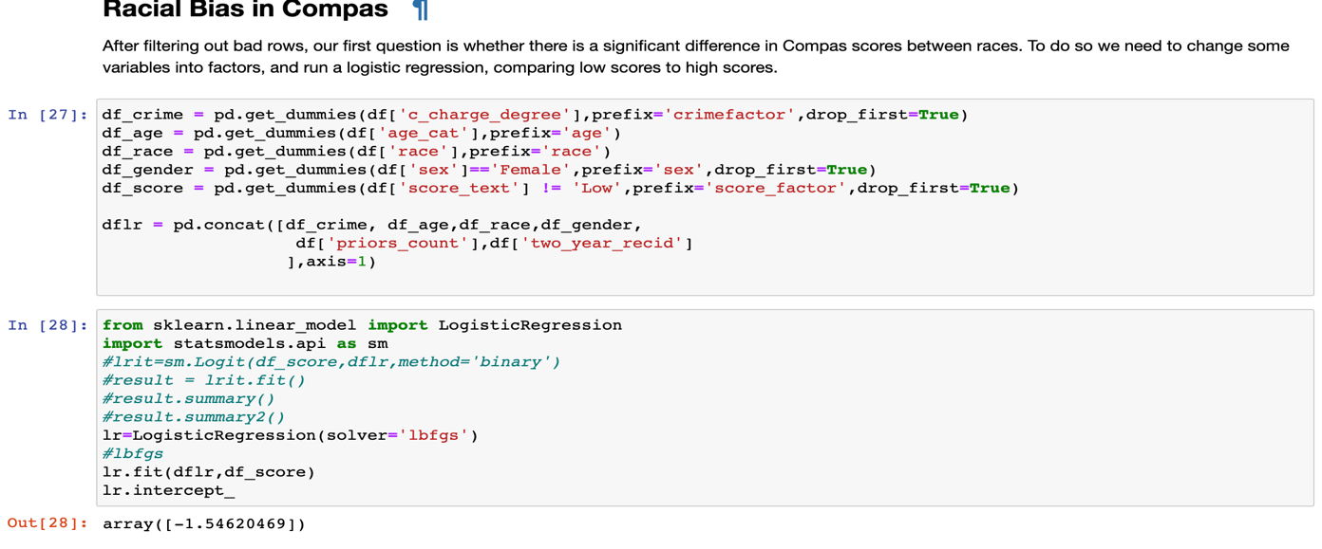

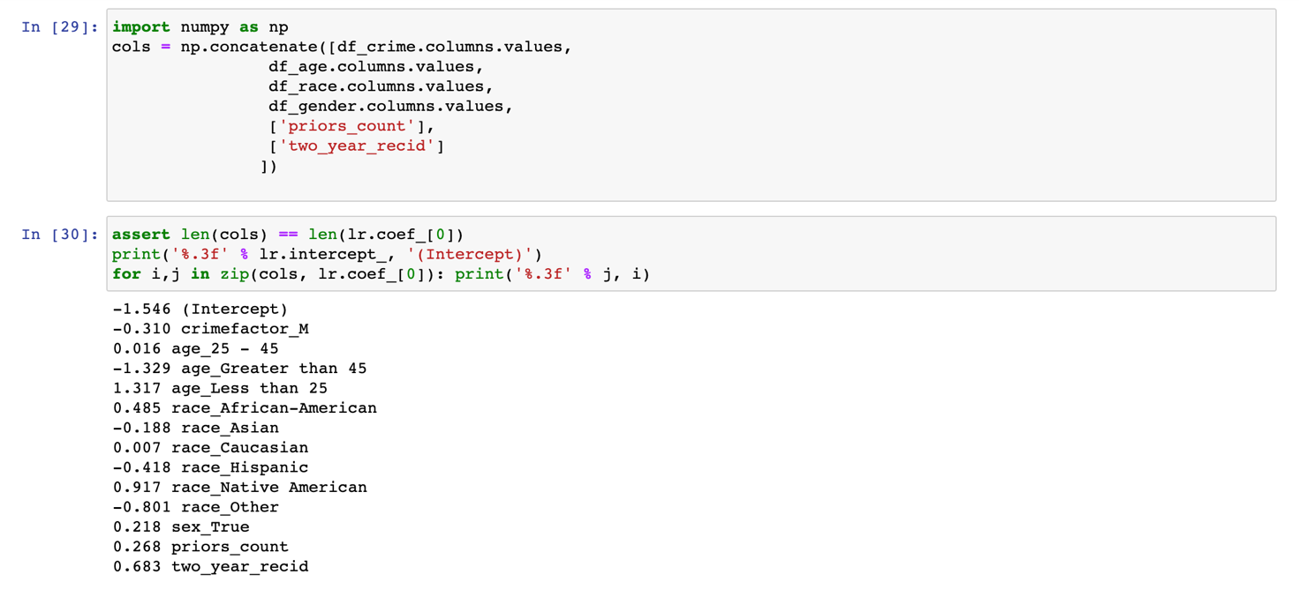

**Summary**

* Our logistic model found that the most predictive factor of a higher risk score was age. Defendants younger than 25 years old were 2.5 times as likely to get a higher score than middle aged offenders, even when controlling for prior crimes, future criminality, race and gender.
* Race was also quite predictive of a higher score. While Black defendants had higher recidivism rates overall, when adjusted for this difference and other factors, they were 46 percent more likely to get a higher score than whites.
* Surprisingly, given their lower levels of criminality overall, female defendants were 19.4 percent more likely to get a higher score than men, controlling for the same factors.

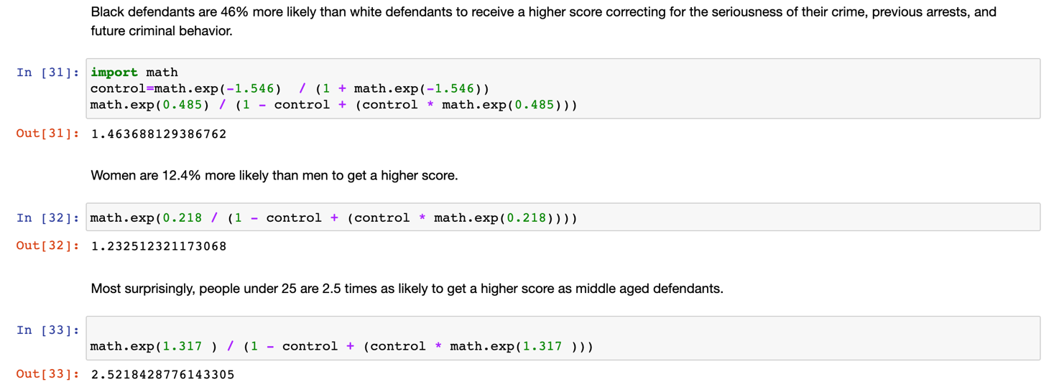

**Task 2:** **Risk of Violent Recidivism Prediction**

Datasets

* The dataset **that is used for Risk of Violent Recidivism is** ‘compas-scores-two-years-violent.csv’.
* It has 4,743 rows. Each row in the file represents a person and is coupled with 54 variables (columns).
* The variables are to be categorized the same like Risk of Recidivism Prediction.

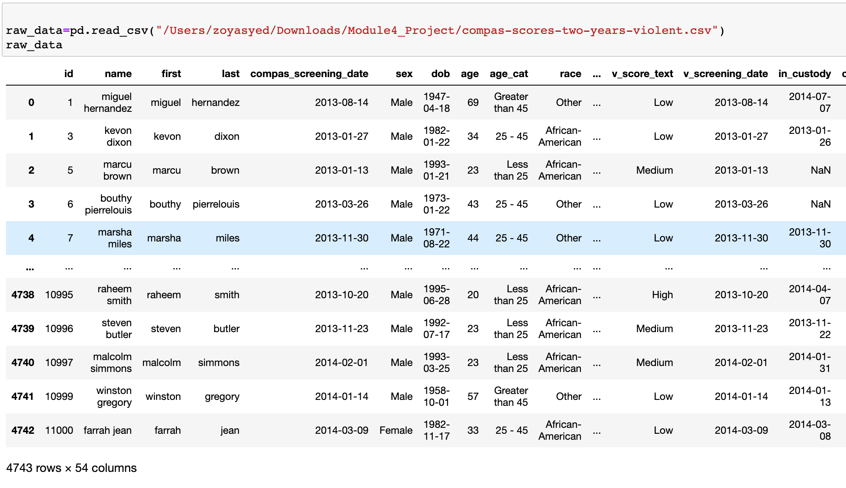

Data Cleaning

* Data cleaning also done same as Risk of Recidivism Prediction
* Before cleaning we have: 4,743 observations; after performed data cleaning we have : 4,020 observations.

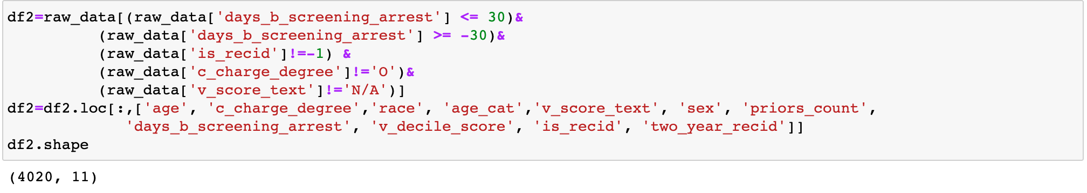

Data Exploration

Analyze demographic breakdown of the dataset:

|  |
| --- |
| **Univariate data exploration** |
| * age_cat (count) * race (count) * score_text (count) * two_year_recid (count, % to Total) |

Here we can see we have count of age category and race count.25-45 age group have large number. And when it comes to race African-American race count is large. 279 defendants with high score. 652 defendants are recidivist within 2 years.

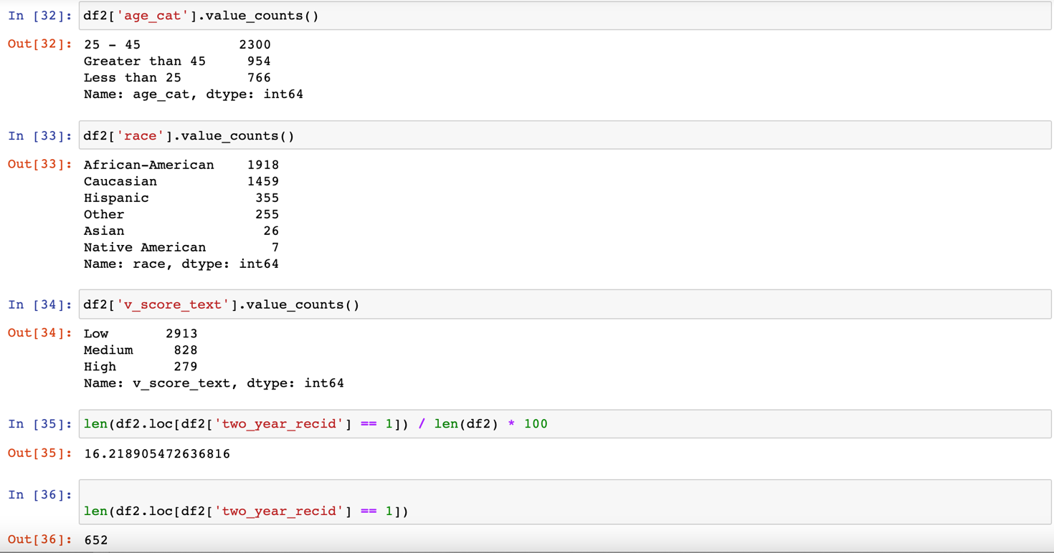

**Visualization**

Here Decile score is classified as 3 categories.1-4 Decile Score considered as Low risk,5-7 Decile score is considered as Medium risk and 8 to 10 Decile score is considered as High score.

* Plotted the simple distribution of COMPAS violent recidivism decile scores between white defendants and black defendants.
* If we see the graph, Black defendant’s count for decile score for 1 to 4 is more and for high risk count is less. Same for the Decile score. If we look at the graph the high risk decile score for White defendants is very low than black Defendants.
* Tabulate all defendants with respect to COMPAS decile score for recidivism.

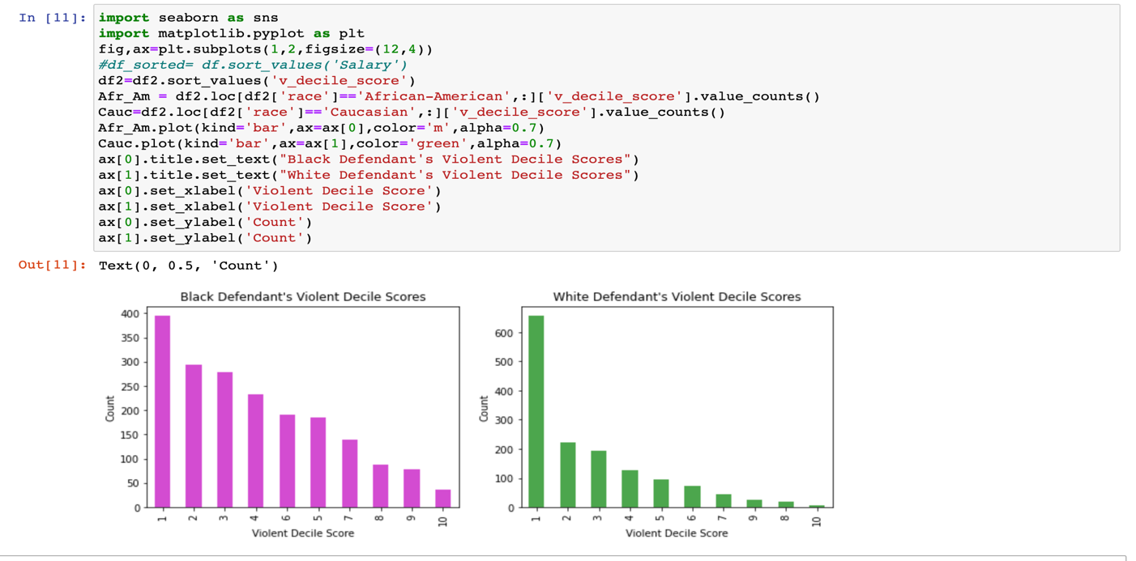

The histograms for COMPAS’s violent risk score also show a disparity in score distribution between white and black defendants. The sample we used to test COMPAS’s violent recidivism score was slightly smaller than for the general recidivism score: 4,020 defendants, 1,918 black defendants and 1,459 white defendants. There were 652 violent recidivists.

The violent score predicts recidivism for black defendants by 70.75% compared to white defendants. Female defendants were 5.3% percent more likely to get a higher score than men, controlling for the same factors.

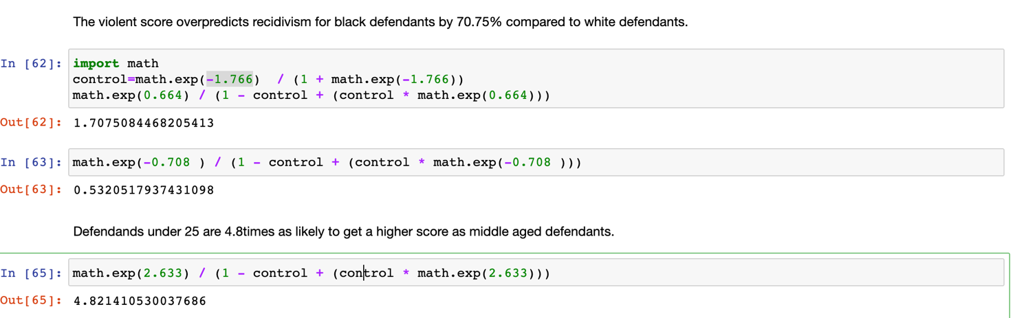

**Data Analysis**

**Test Racial Bias in the Category of Risk of Violent Recidivism**

We analyzed 4,020 people who were scored for violent recidivism over a period of two years (not including time). We ran a logistic regression model with same set of predictors as earlier.

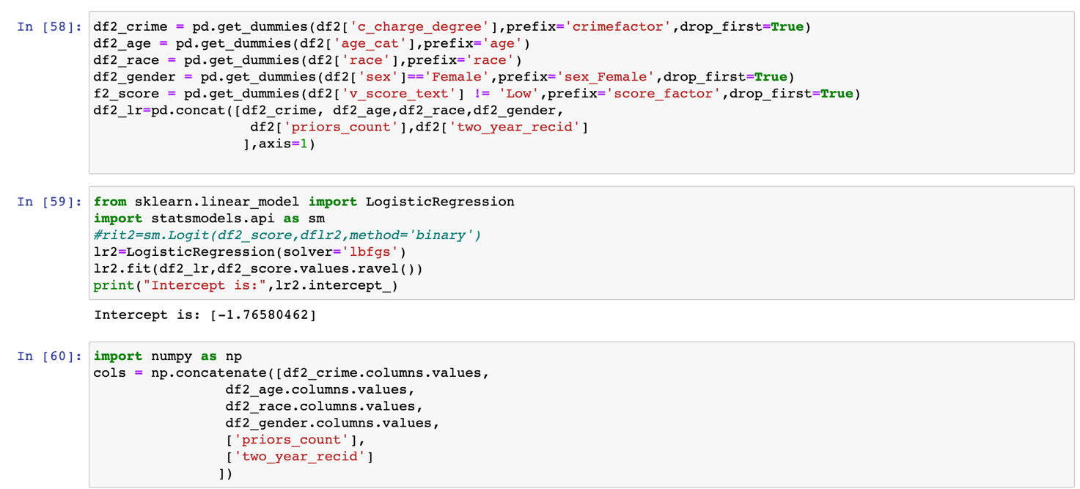

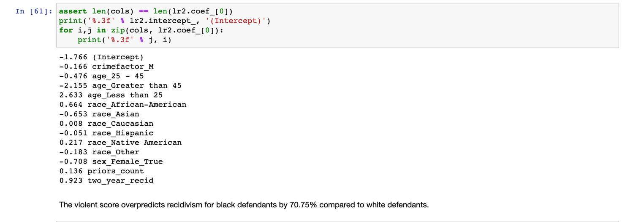

**Summary**

* Age was an even stronger predictor of a higher score for violent recidivism. Our regression showed that defendants under 25 were 4.8 times more likely to get a higher score than middle age defendants, when correcting for criminal history, gender, race and future violent recidivism.
* Race was also predictive of a higher score for violent recidivism. Black defendants were 70.75 percent more likely than white defendants to receive a higher score, correcting for criminal history and future violent recidivism.



Tabulation of Test Results from Logistic Regression Model

|  |  |  |
| --- | --- | --- |
|  | **Logistic Reg. on Recidivism** | **Logistic Reg. on Violent Recidivism** |
| **Age group** | Defendant under 25 were 2.5 times more likely than 25-45 age group receiving high COMPAS scores | Defendants under 25 were 4.8 times more likely than middle age defendants to receive a high COMPAS scores |
| **Race** | Black defendants were 45% more likely than white defendants getting high COMPAS scores | Black defendants were 70.75% more likely than white defendants to get a higher COMPAS score |
| **Gender** | Female inmates 19.4% more likely than male inmates getting high COMPAS scores. | Female inmates 5.3% more likely than male inmates getting high COMPAS scores. Female are less violent as per model. |

**Task 3: Accuracy of Prediction in Recidivism Category**

**Datasets**

* The datasetthat is used for predicting accuracyof Recidivismis ‘cox-parsed.csv’.[13419 rows x 52 columns]
* Each row in the file represents a person and is coupled with 52 variables (columns).

**Data Cleaning**

* To prepare for the counting model, we are to remove people when they were incarcerated.
* Due to erroneous jail data, we are to filter out the rows that have an end date more than the start date.
* Removed the duplicate rows from id column and removed N/A values from Score_text field.
* Before treated: 13,419 observations; after treated: 10,314 observations.

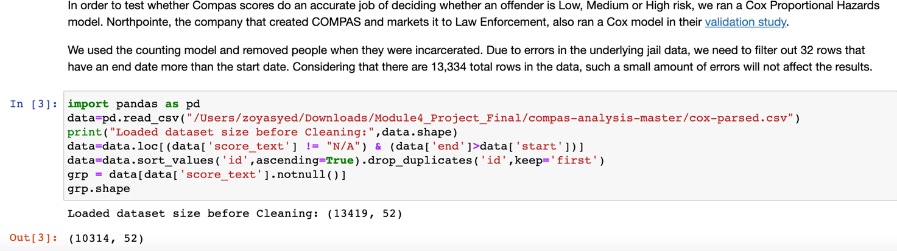

Data Exploration

Analyze demographic breakdown of the dataset:

In this stage check the race_factor count and score_factor which are considered as main for prediction.

|  |
| --- |
| **Univariate analysis** |
| * score_factor (count) * race_factor (count) |

Here we can see 1952 recidivist got High Score value. And 5147 defendants are African Americans.

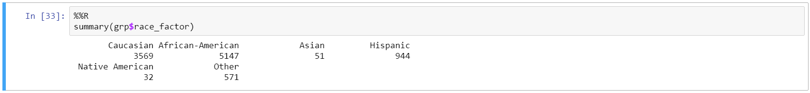

**Data Analysis**

To test COMPAS’s predictive accuracy, we fit a Cox proportional hazards model to the respective data. A Cox model allows us to compare recidivism rate while controlling for time. **Cox regression** (or proportional hazards **regression**) is method for investigating the effect of several variables upon the time a specified event takes to happen. In the context of an outcome such as death this is known as **Cox regression** for survival analysis. Here by using Cox model we are checking how many of them are recidivic.

**Cox Model for Score Factor Bias**

Here by using Cox model we are checking the chance of becoming recidivic for those whose score is medium or high.

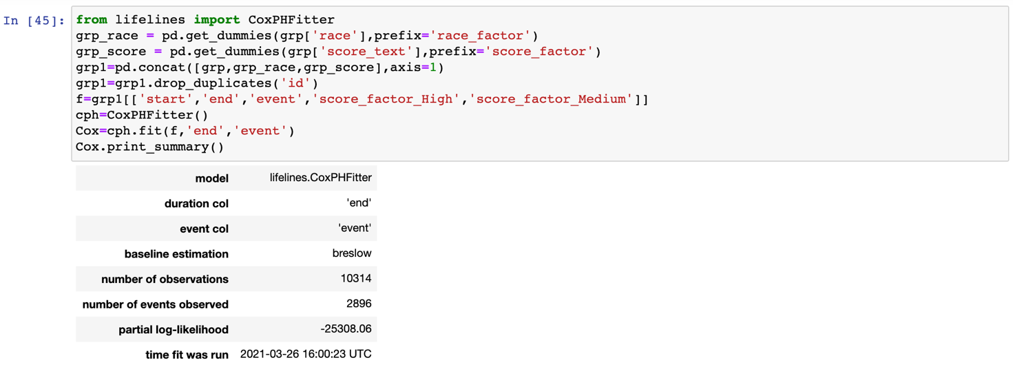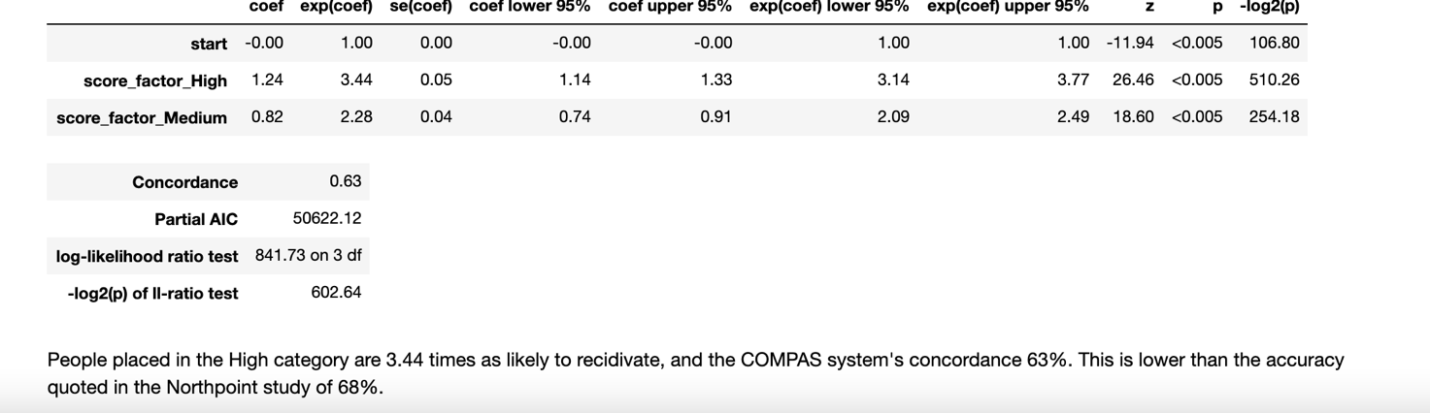

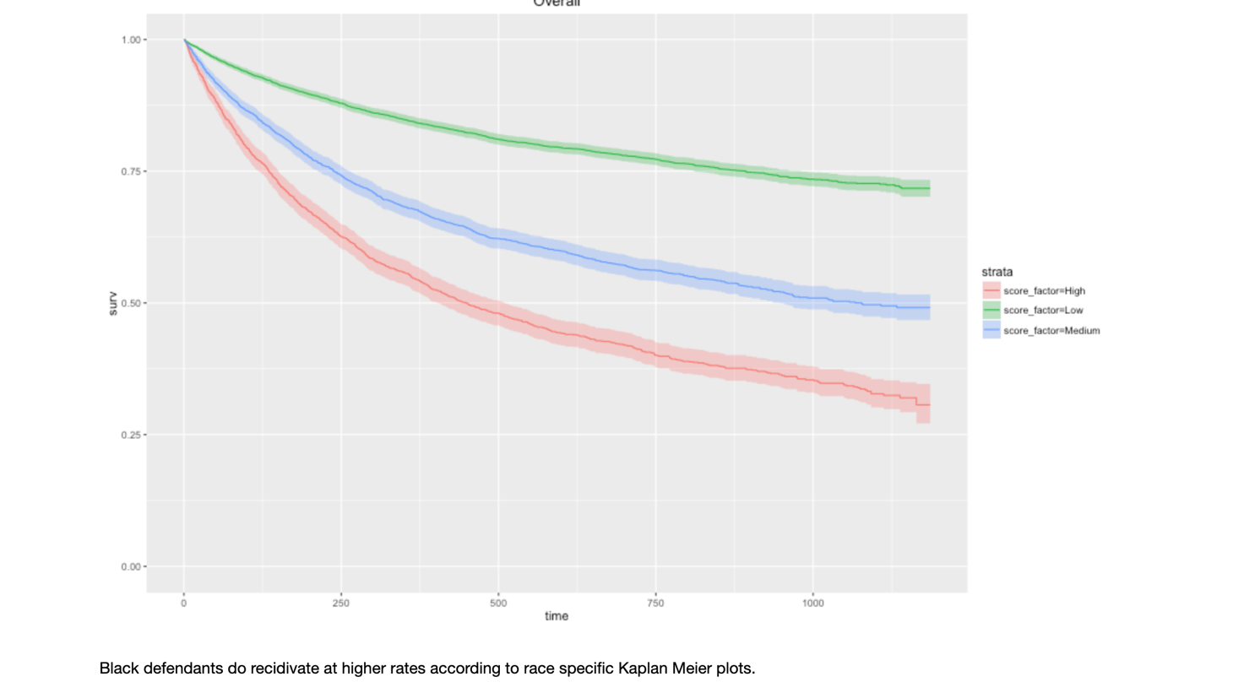

From this model we can see that the people who are having high score category are 3.44 times as likely to recidivate. Compass systems concordance 63 is 63%.This is lower than the accuracy quoted in Northpoint study which is 68%.From the above graph we can see that the survival rate High factor is very less. The probability of high score defendants commit the crime for second time is only 25%.From this we can say that there may be chance to have bias based on race and age factor.

Cox Model with Decile scores:

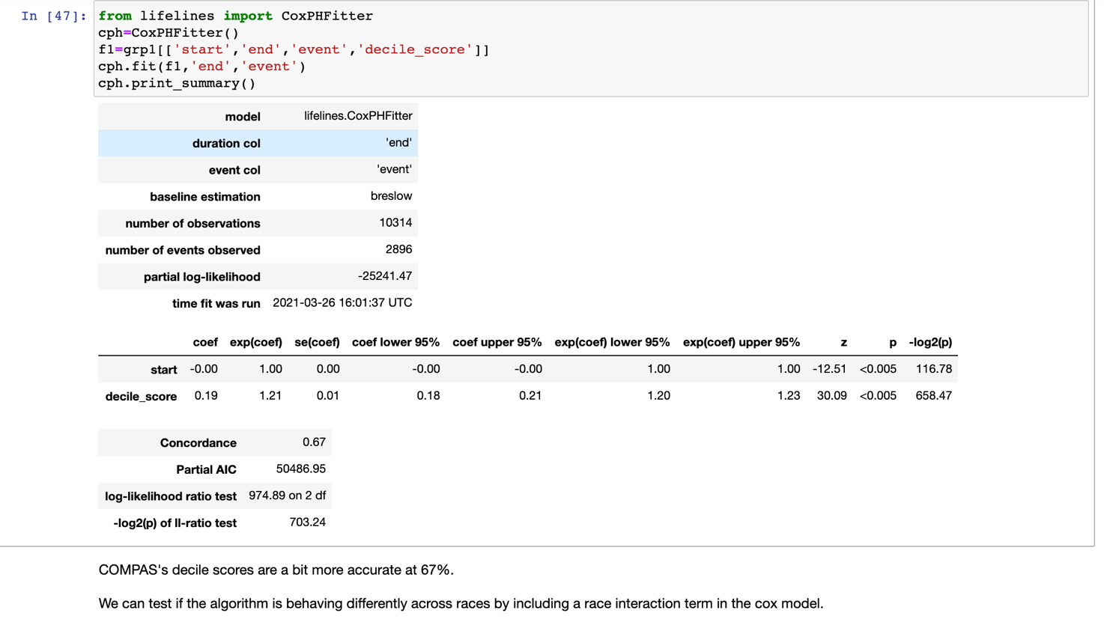

Here the model predicted accuracy of 67%.We can test the algorithm is behaving differently with races by including race interaction term in the cox model.

**Cox Model for Racial Bias**

Across every risk category, black defendants recidivated at higher rates according to race specific Kaplan Meier plots. The race specific models have similar concordance values of 62.5% for whites and 62.3% for blacks. Note: The relevant codes are appended below including summaries of Cox model for datasets: fit, white fit and black fit.

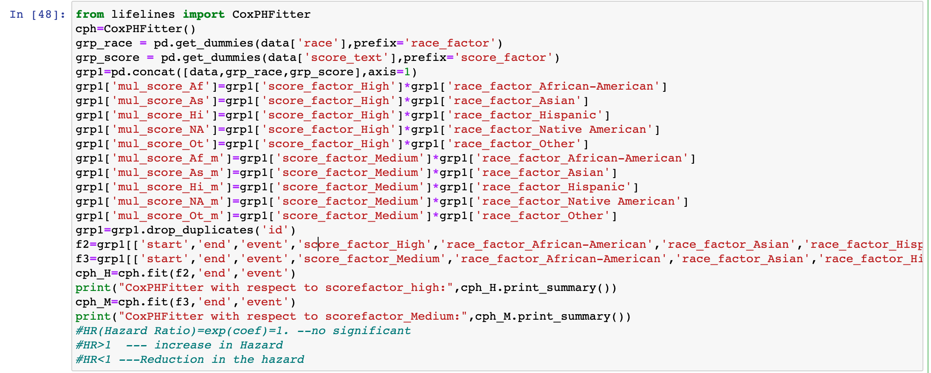

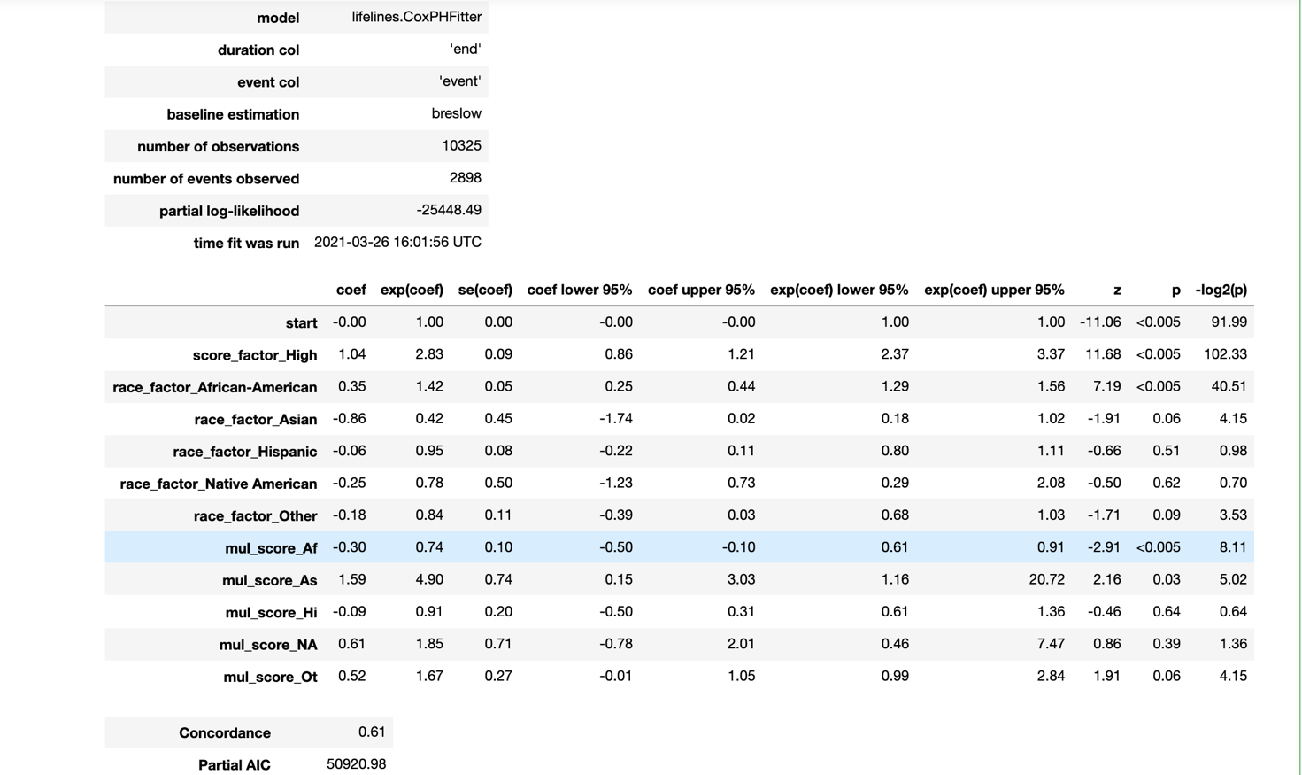

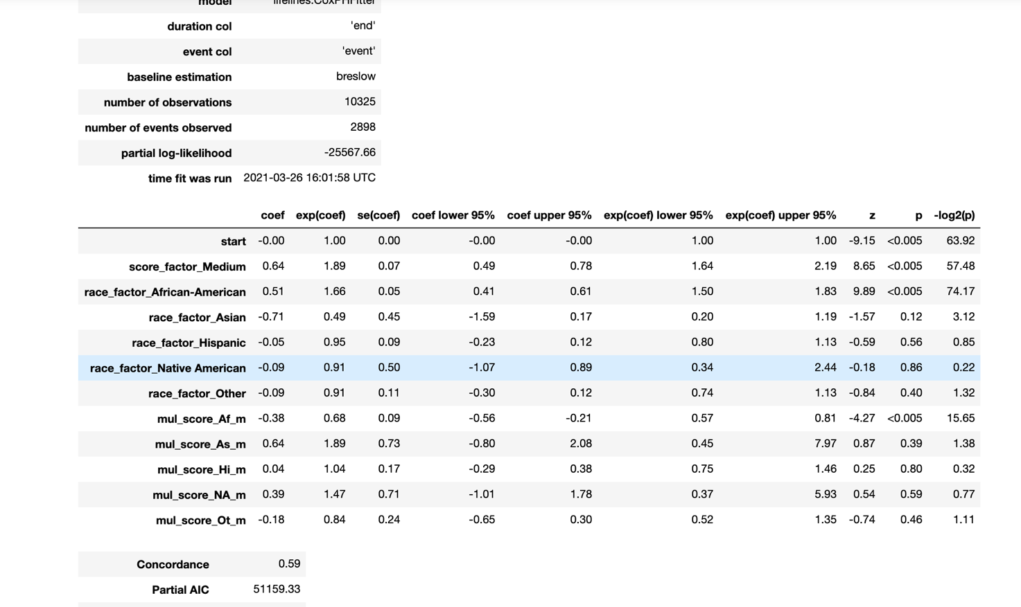

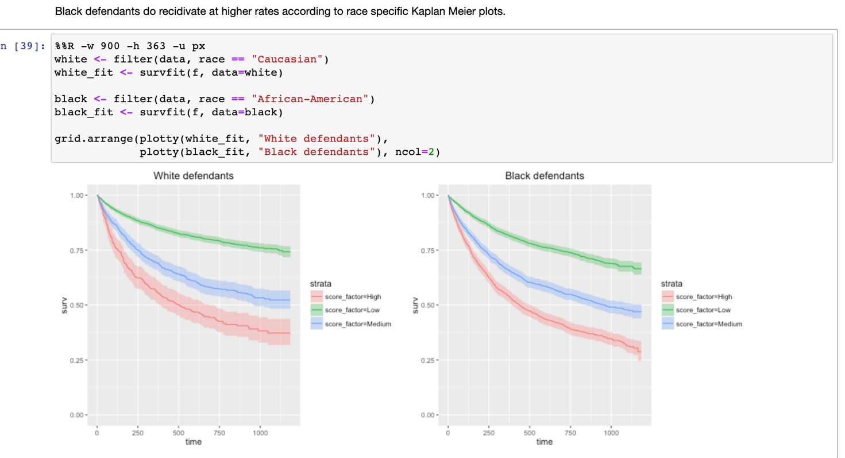

From this plot we can say that black defendants do higher rate of recidivate according to Kaplan meier plots.

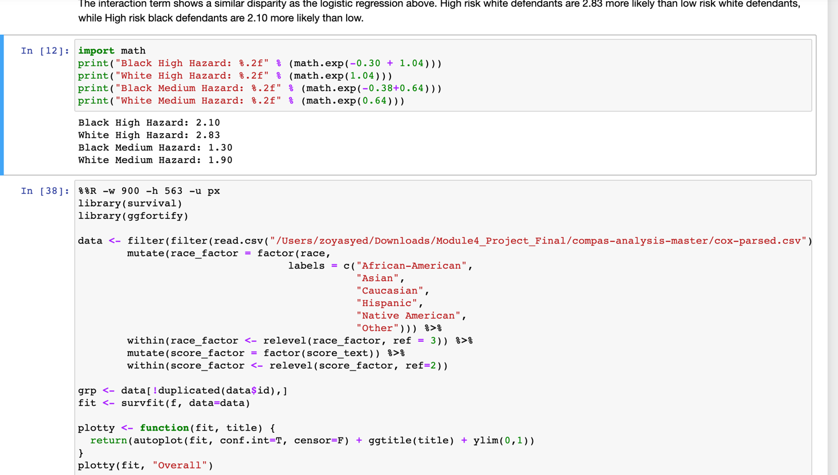

From this model we can see that The interaction term shows a similar disparity as the logistic regression above. High risk white defendants are 2.83 more likely than low risk white defendants, while High risk black defendants are 2.10 more likely than low.

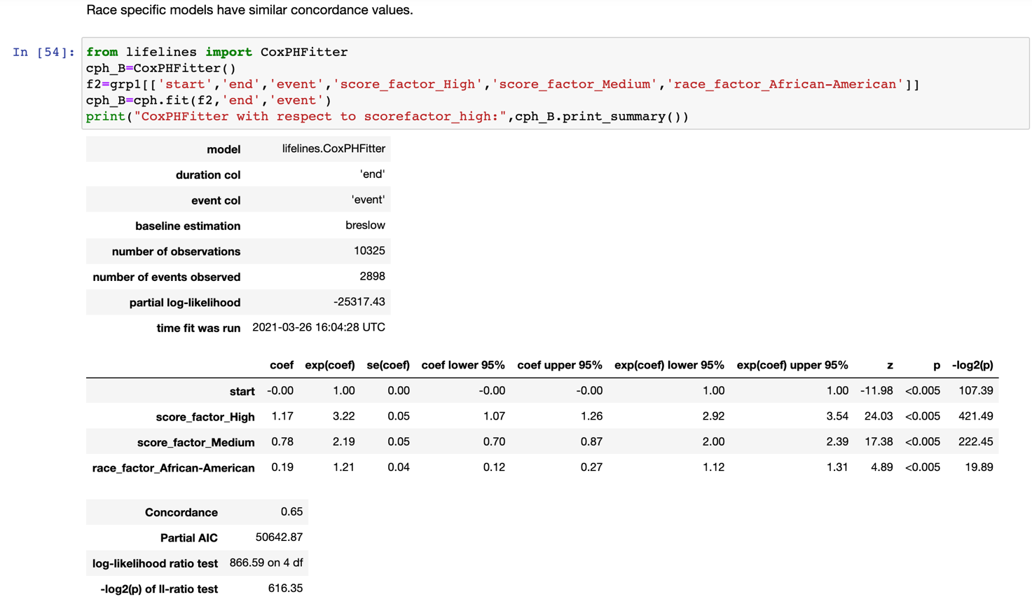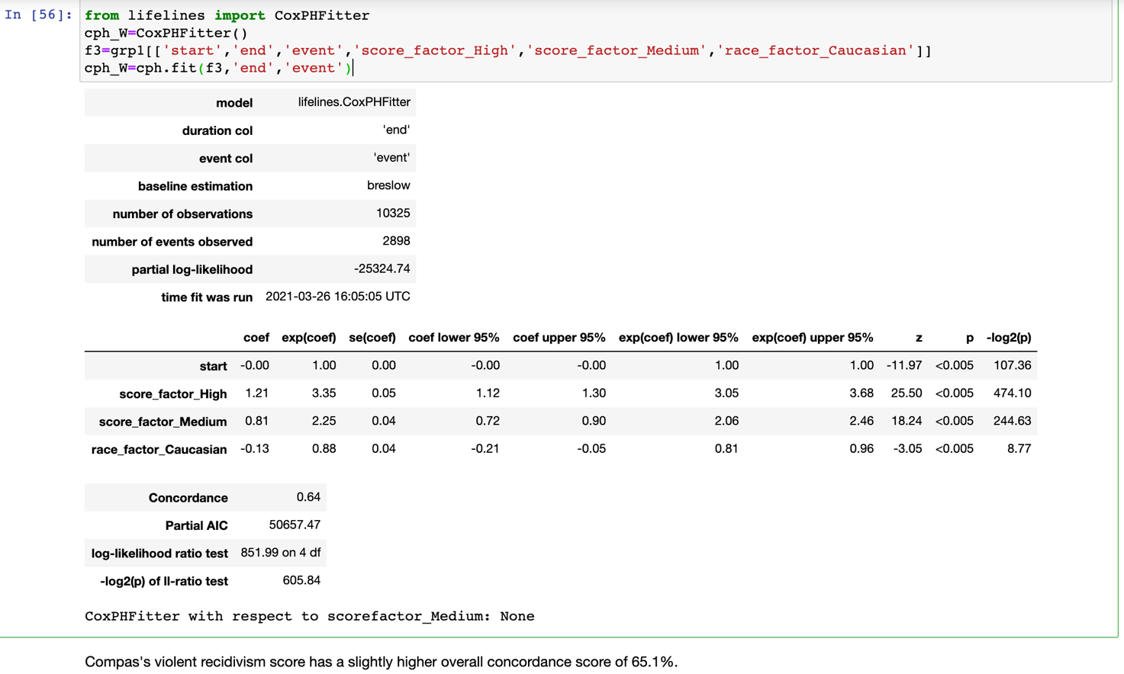

Here we can see that the concordance for both whites and blacks are nearly same values.

**Cox Model for Direction of Bias**

The above analysis shows that the COMPAS algorithm does overpredict African-American defendant's future recidivism, we will want to explore the direction of the bias. We can discover fine differences in overprediction and underprediction by comparing COMPAS scores across racial lines.

Overall, the false positive rate is 32.35%. That number is higher for African Americans at 44.85%. And lower for whites at 23.45%. This implies under COMPAS black defendants are 91% more likely to get a higher score and not go on to commit more crimes than white defendants after two year. COMPAS scores misclassify white reoffenders as low risk at 70.4% more often than black reoffenders. Note: Relevant codes are appended below.

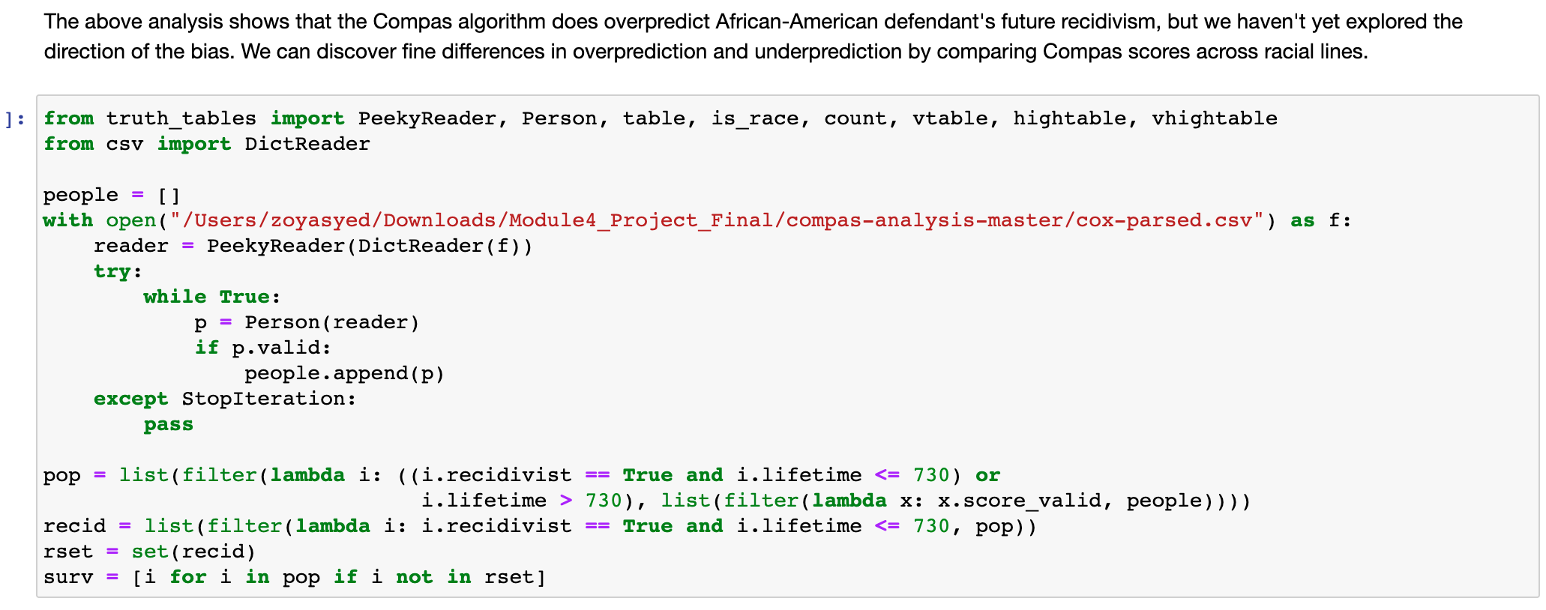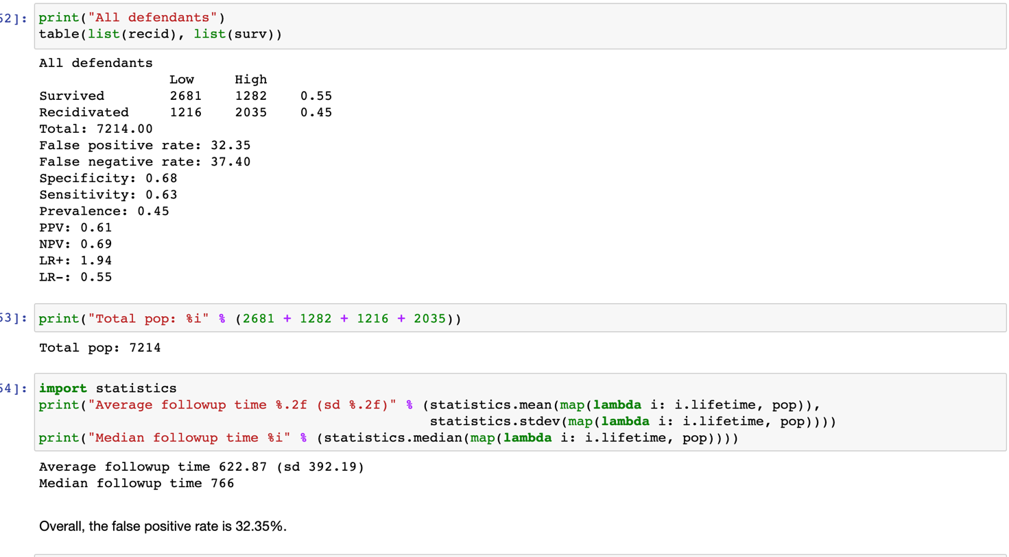

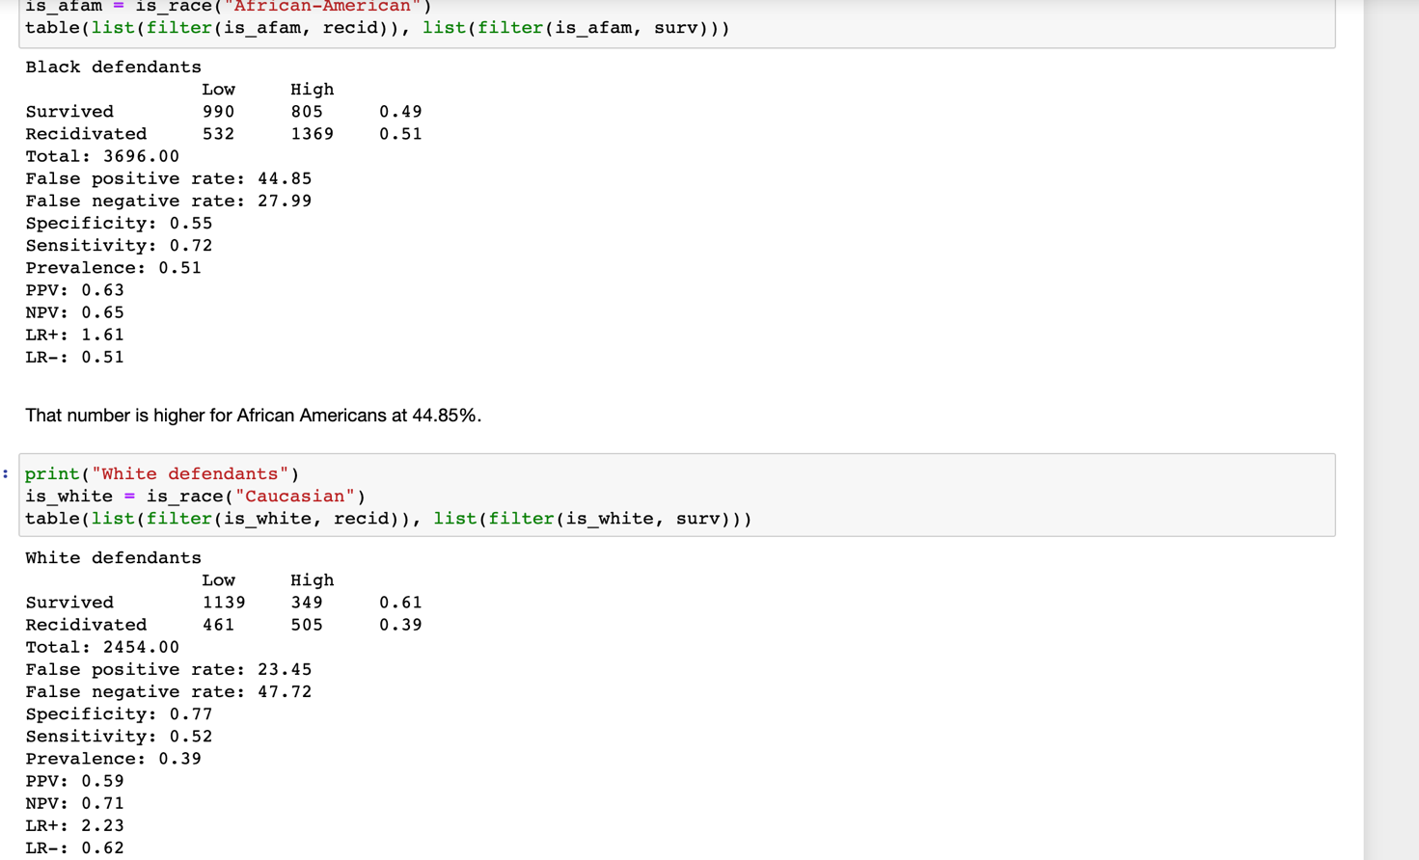

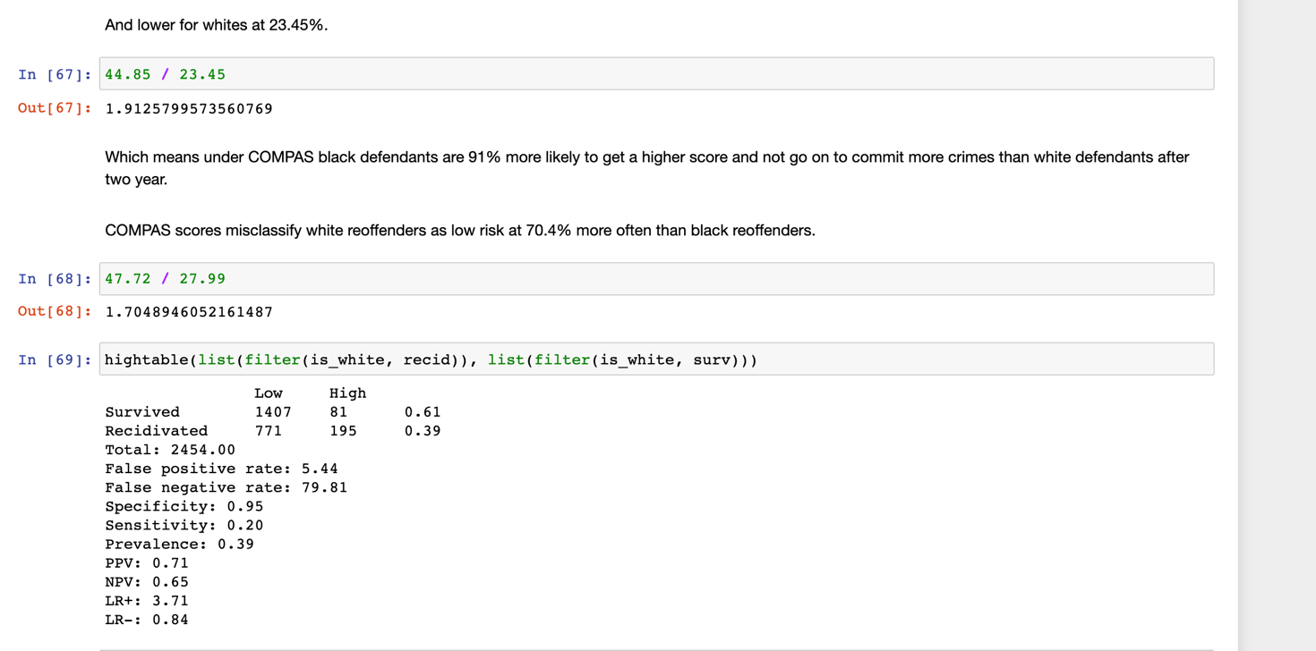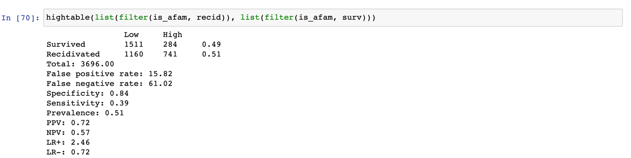

**Cox Model for Gender differences in COMPAS scores**

In terms of underlying recidivism rates, we can look at gender specific Kaplan Meier estimates. There is a striking difference between women and men. As these plots show, the COMPAS score treats a High risk women the same as a Medium risk man.

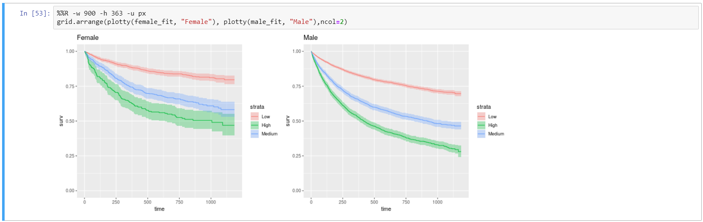

**Task 4:**

**Accuracy of Prediction in Violent Recidivism Category**

**Datasets**

* Here we used ‘‘cox-violent-parsed.csv” file for predicting Violent Recidivism.
* It has 18,316 rows. Each row in the file represents a person and is coupled with 52 variables (columns).

**Data Cleaning**

* To prepare for the counting model, we are to remove people when they were incarcerated.
* Due to erroneous jail data, we are to filter out the rows that have an end date more than the start date.
* Removed the duplicate rows from id column and removed N/A values from Score_text field.
* Before treated: 18,316 observations; after treated: 10,996 observations.

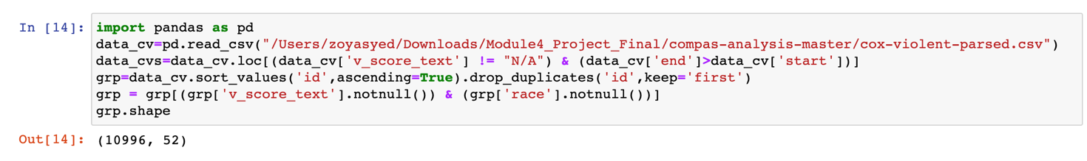

**Cox Model for Racial Bias**

Across every risk category, black defendants recidivated at higher rates according to race specific Kaplan Meier plots. The race specific models have similar concordance values of 64 % for whites and 65% for blacks. Note: The relevant codes are appended below including summaries of Cox model for datasets: fit, white fit and black fit.

Overall, there are far fewer violent recidivists than general recidivists and there isn’t a clear difference in the hazard rates across score levels for black and white recidivists. These Kaplan Meier plots show very low rates of violent recidivism.

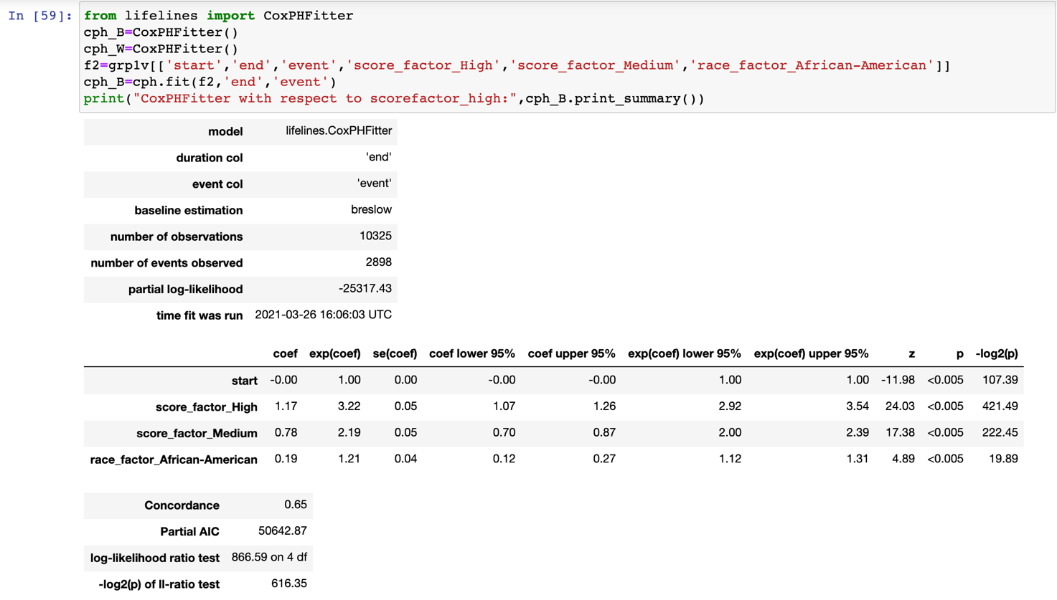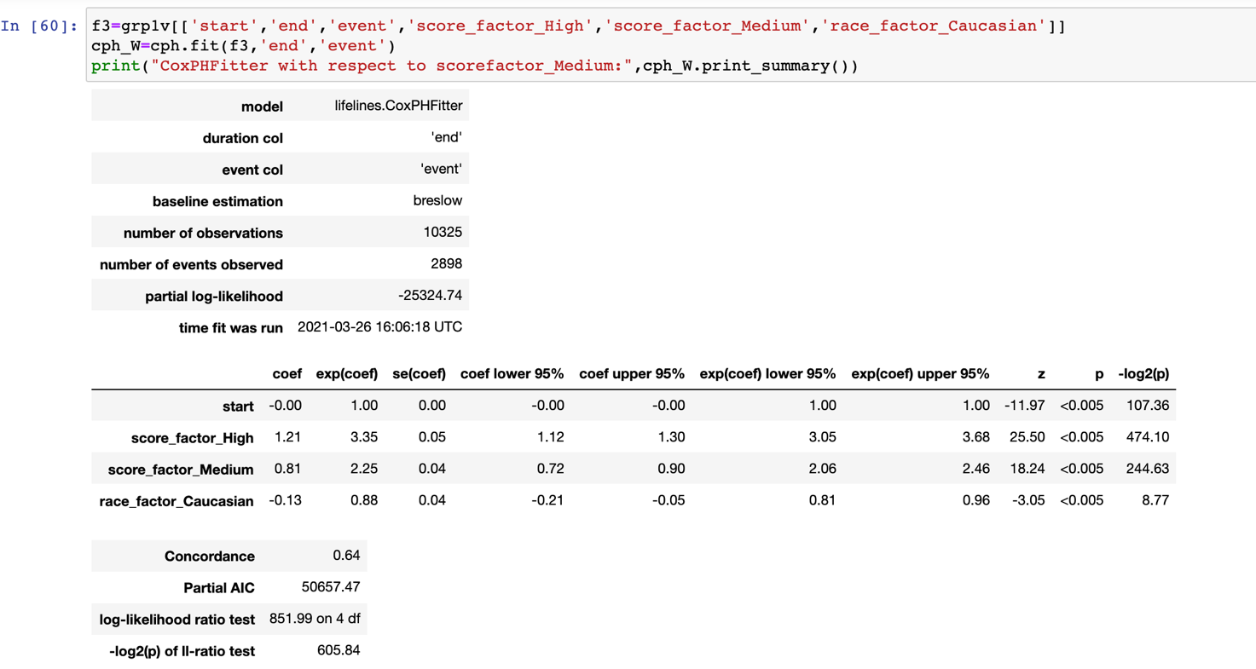

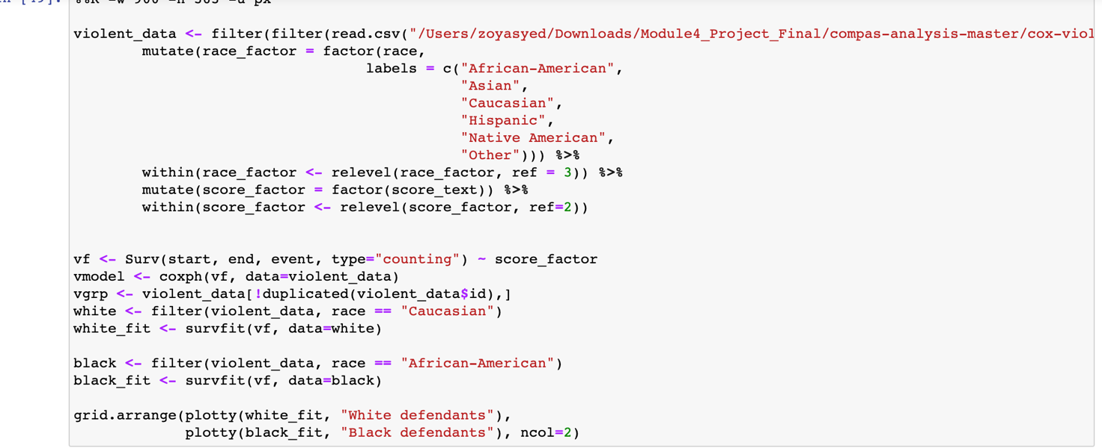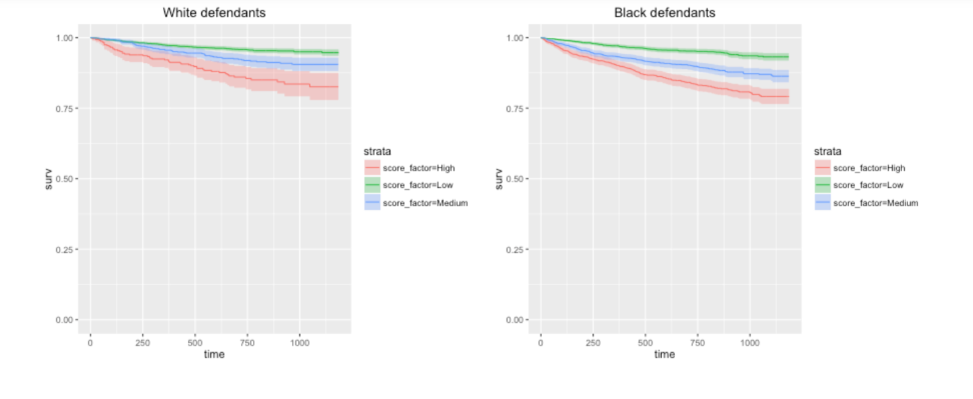

**Cox Model for Direction of Bias:**

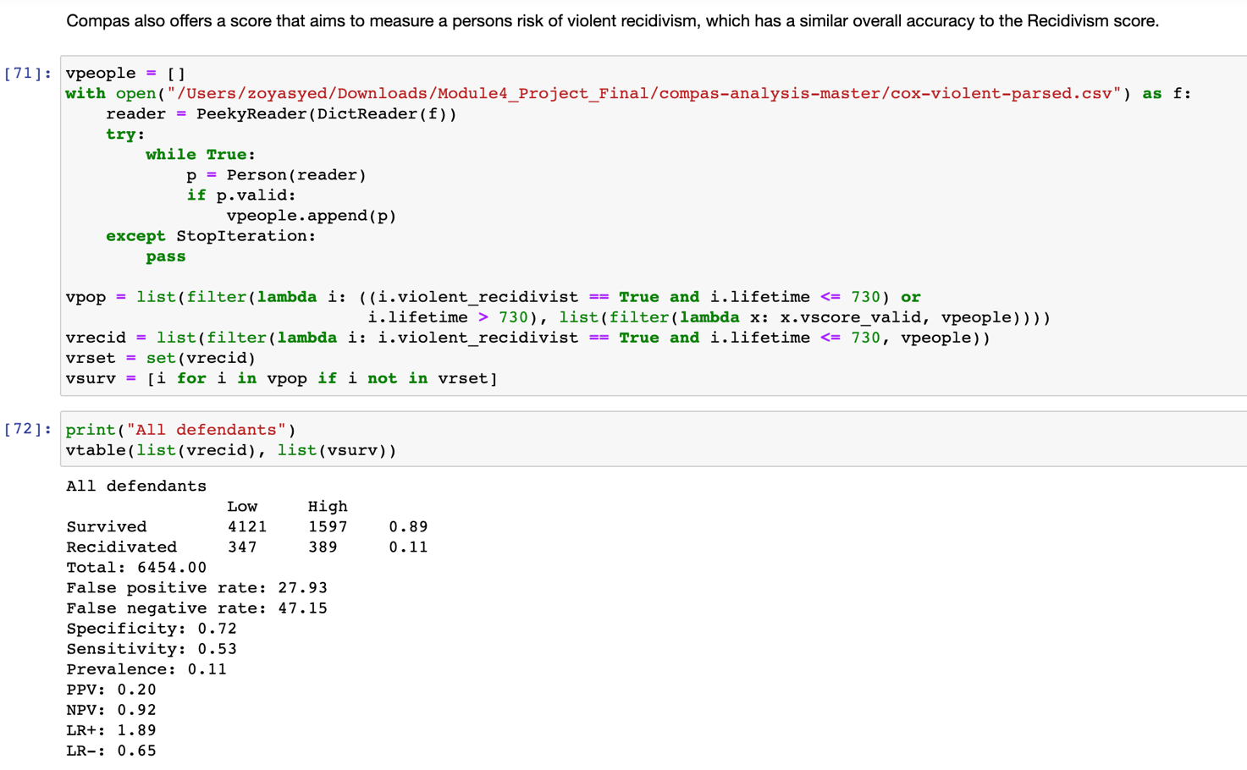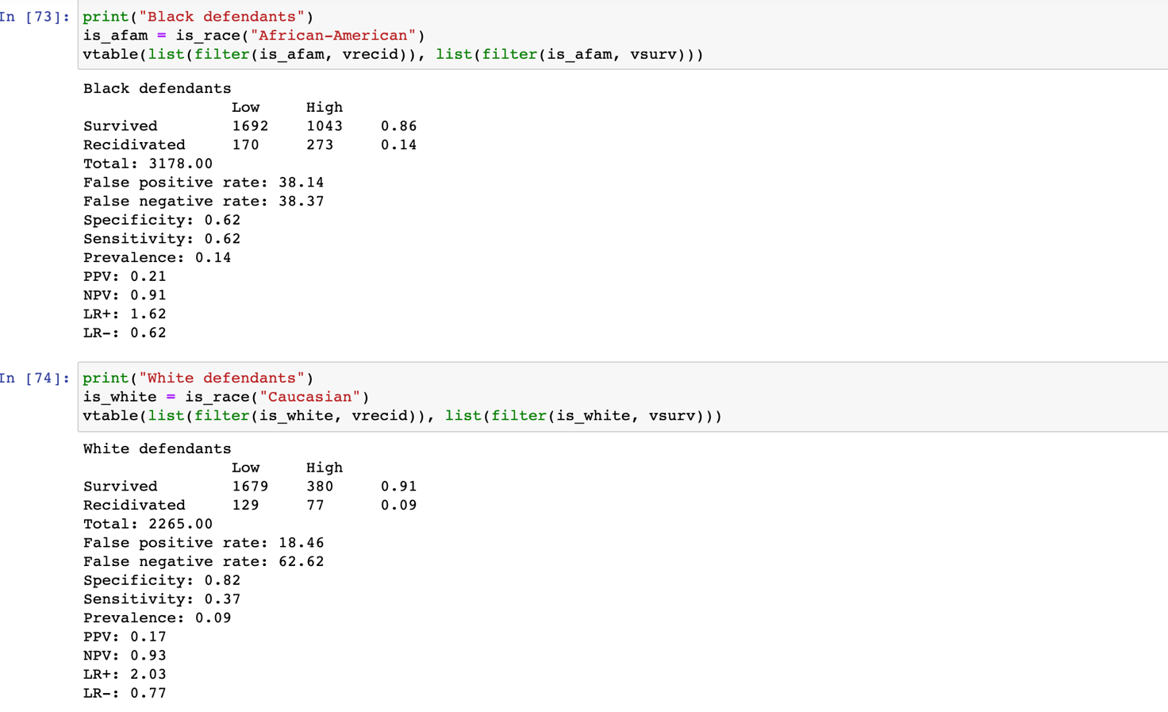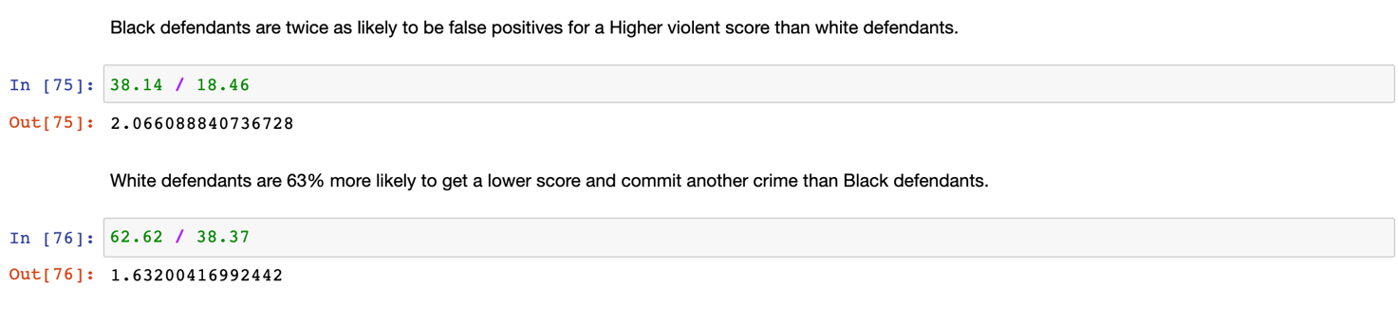

Black defendants are twice as likely to be false positives for a Higher violent score than white defendants. White defendants are 63% more likely to get a lower score and commit another crime than Black defendants.

**Gender difference in compass scores:**

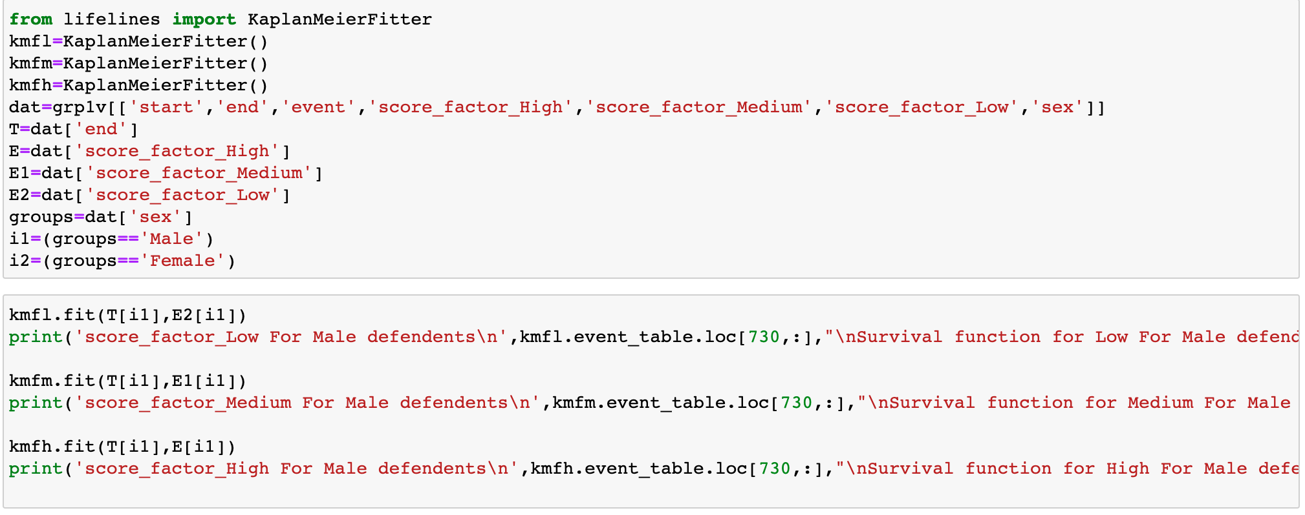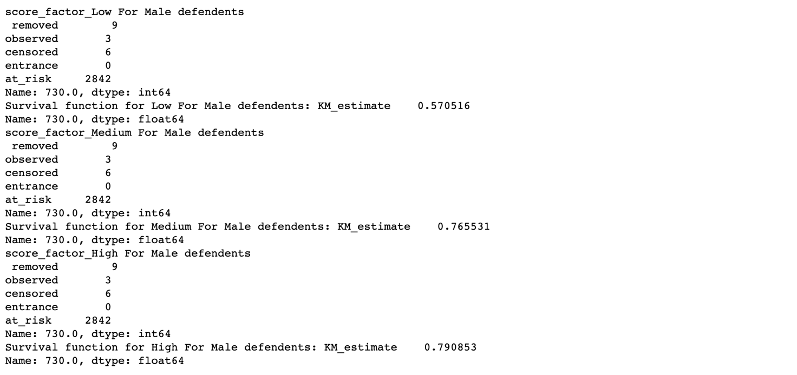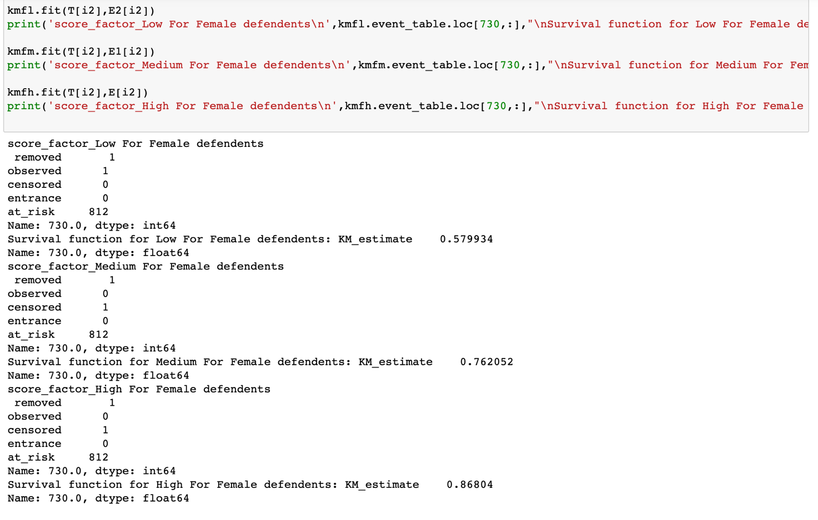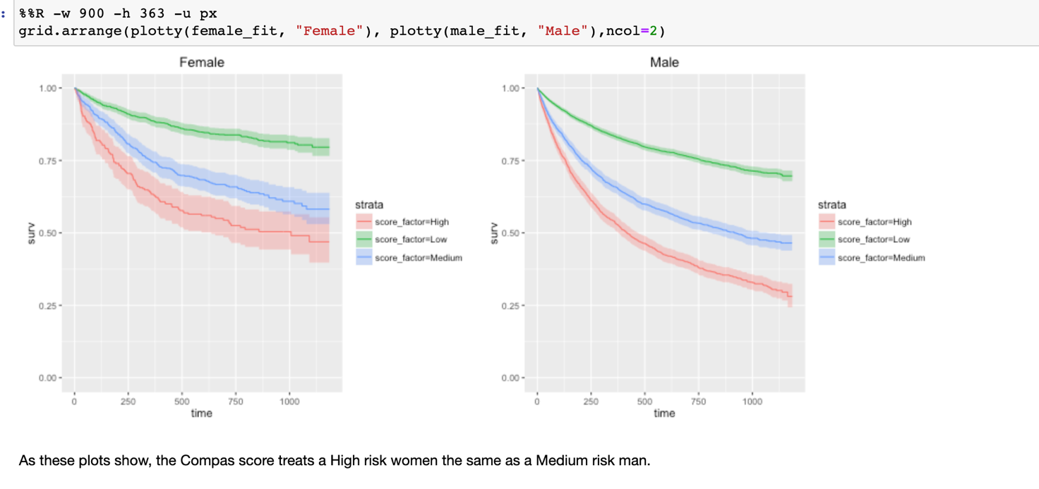

High score factor Male defendants have highest probability of recidivic than female and compass score treats high risk women the same as a medium risk man.

**Task 5:** **IRAC Analysis of a Using Sentencing Algorithm**

**Scenario**

The County Jailhouse in State Z in the United States is working on reducing recidivism, which is the tendency of a convicted criminal to reoffend. In order to accomplish their objective, the Jailhouse hired a data scientist to design an algorithm to predict the likelihood of recidivism of current inmates. The data inputs for this new algorithm include variables such as age, prior convictions, race and gender. The Jailhouse will use the predictions to determine whether or not to release inmates who come up for parole, or to grant early release from their sentence.

One of the Jailhouse employees shared the plans to use the new algorithm with a friend who is an attorney at a local non-profit justice organization. In response to the plans, the organization filed a lawsuit against State Z to prevent the Jailhouse from using the algorithm for parole decisions. State Z and the Jailhouse are contesting this lawsuit and want to move forward with use of the algorithm.

If you were the judge deciding this case, what would you rule? Apply the IRAC method to identify the legal issue you think arises out of these facts, and any rule or policy you think is on point. Then apply the rule or policy to reach your conclusion.

* **Issue**: As per Northpointe algorithm the score is giving with respect to race, gender and age .By using this data to predict recidivism is lawful.
* **Rules**: The US law/constitution say about using these factors is that, all the people are same in the justice no matter of skin, age or gender. The **equal** protection clause in the 14th **Amendment** means that **states** must treat all their citizens equally. **States** can't favours men over women, whites over blacks, or heterosexuals over gays

The U.S. Constitution protects individuals from government actions, that infringe on civil and political human rights. When the government takes an action that treats people differently with respect to liberty on the basis of race and/or gender, the courts apply a strict test (for race) and/or scrutiny test (for gender) that requires the government to show it has a compelling purpose (for gender) and/or significant purpose (for race) for the difference in treatment, and to prove that the only way to achieve this purpose is the means they have chosen.

**Application:**

The algorithm at issue uses race and gender data as inputs. Both are protected classifications, and so this use will require scrutiny. It is revealed that the County Jailhouse has a purpose for using the algorithm: to reduce recidivism. While that purpose alone is lawful and important to the community, State Z will have to prove that it is at least a significant purpose (for gender), and at most a compelling purpose (for race). Subsequently, assuming State Z can show this, it will still need to prove that using these inputs are the only way to accurately predict recidivism. State Z will be challenged to show there are no other options, or data inputs, which it can use to as accurately predict recidivism in making parole decisions.

**Conclusion:**

Because State Z has no proof based on the facts here that using race and gender is the only way to predict recidivism of County Jailhouse inmates, use of these data inputs is a violation of inmate rights and unconstitutional. County Jailhouse is not permitted to use this algorithm for parole decisions. The court finds for the non-profit justice organization.

1. **Conclusion**

This project involves studying a data mining lab with focus on algorithmic fairness and criminal justice. The lab and the datasets are released by ProPublica for their analysis project on COMPAS (which stands for Correctional Offender Management Profiling for Alternative Sanctions). We are given a series of subtasks including those analysis work on the datasets and an IRAC scenario for this particular lab.

Upon completion of this project, we were able to achieve the project outcome by:

* Obtaining summarized views on the accuracy of predicted recidivism rates, violent recidivism rates and the overall accuracy of COMPAS in respective categories.
* Performing calculations on data and algorithms using R and Python in Jupyter
* **Performing visualizations** on data using R and Python in Jupyter
* IRAC analysis with respect to this particular lab

The instances in this project manifest the machine bias issue that could **probably be** due to unconscious bias. The unconscious bias could have entered the data processing without us noticing it when it used historical data that was itself the product of bias. Moreover, the algorithm could have factored in features that unfairly harm some person or group, in this case, the black defendants.

At this age of big data, technologies that use machines and algorithms will certainly be part of it that they will reorganize the way we live, work and interact socially. Therefore we must think about how to design and build our systems, that are fueled by algorithms in the back end, in ethical way before they goes to market, before they cause problem. By doing so, we are designing the data revolution so that we can avoid ecological crisis in our digital space as well as ensure its sustainability.

As a recommendation, we hope a data dictionary could be provided for this lab which we believe will be able to profusely reduce the amount of time spent on getting context of the data for future students.

Appendix:

